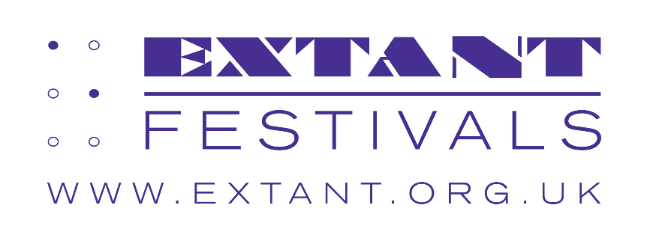

Extant Showcase of Visually Impaired Artists

Edinburgh Festival Fringe

18 August 2026

Underbelly Jersey, McEwan Hall, Bristo Square, Edinburgh, EH8 9AG

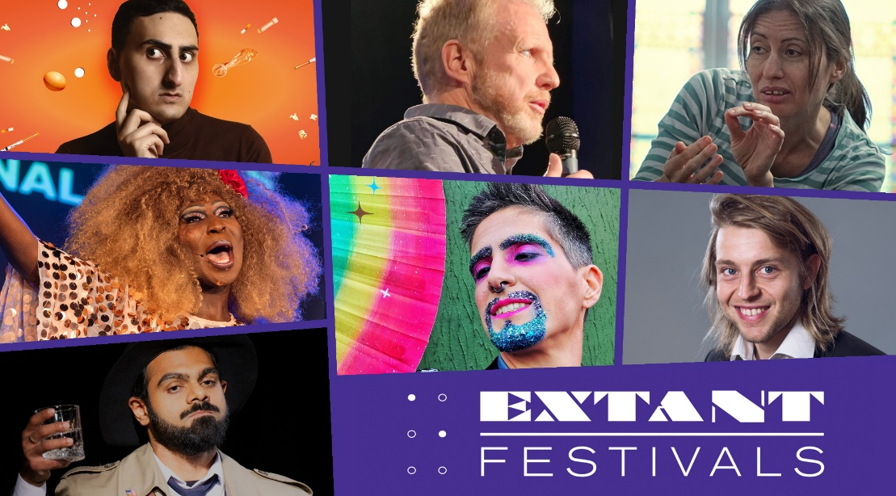

Through our pioneering ground-breaking productions, advocacy programmes and initiatives, Extant has been a force for driving industry change towards higher creative standards and access for visually impaired people since 1997. In 2024, we turned our attention to the Edinburgh Festival Fringe, driving real change across the festival through our pioneering ‘Ladder of Access’ approach. This supports venues and artists to introduce visually impaired access into their work, and it has shifted the dial: from under 1% of shows with visually impaired access in 2024, to over 12% at this year’s festival.

While it’s significant and meaningful to improve the situation for audiences attending Fringe, at Extant, alongside developing our own creative pathways, we’ve always championed the work and voices of visually impaired artists, theatre makers, creators and thinkers. Naturally then, in this showcase we have created a platform for the incredible artists who we have worked with over the years to astound with their brilliant, creatively accessible work. From theatre to dance to comedy and cabaret, there’s no limits to the talent of Extant’s collaborators and co-conspirators. We hope you are as excited by the work we have selected as we are!

Dr Maria Oshodi, Extant Artistic Director
Showcase Performances in order of appearance

Tito Bone – Host – medley from ‘An Effing and Blinding Cabaret’ by Extant

Dr. Maria Oshodi – presentation on Extant Hive

Neil Skene – comedy set: ‘The Belligerency of Blindness’

Aarian Mehrabani – excerpt from ‘How’s Your Head?’

Holly Thomas – presentation on Half Light Projects

Shashank Sharma – work in progress: ‘The Stuff that Dreams are Made Of’

Ebony Rose Dark – work in progress: ‘Growing Nostalgia’

Tom Skelton – excerpt from ‘VIP (Visually Impaired Papa)’

Tito Bone – excerpt from ‘An Evening with Tito Bone: The World is Burning so Please Come to my Drag Show’

Showcase Production Team

Stage Manager: Leigh Arthur
Producer: Louisa Sanfey for Extant
Administration: Ellen Jupp for Extant
Access Workers: Morag Innes, Nicky Tuxworth, Jessica Ross

Extant Team

Artistic Director: Dr Maria Oshodi
Operations Director: Ian Abbott
Accounts: Kate Kempin
Administrator & Project Coordinator: Ellen Jupp
Artist Development Manager: Louisa Sanfey
Enhance Programme Manager: Caroline Jeyaratnam-Joyner

This showcase is dedicated to the memory of visually impaired actor and musician Sandy Easton, one of the original Extant Effing and Blinding cast members, who toured with the show to Edinburgh Festival Fringe in 2007.

With thanks to: Arts Council England, Esmee Fairbairn Foundation, Postcode Society Trust and players of People’s Postcode Lottery, Underbelly.

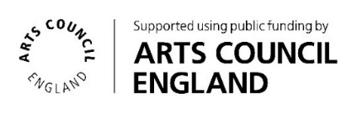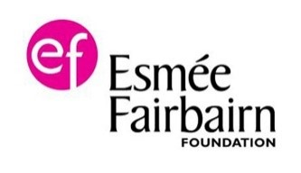

Help Extant continue to create world class award-winning work by donating at www.extant.org.uk/support-us/
Showcase Artist Profiles in alphabetical order

Aarian Mehrabani

Aarian Mehrabani is a multi award winning comedian, writer and actor. He is Co-Founder & Co-Artistic Director of the theatre company FlawBored, and co-wrote the company’s smash hit play “It’s A MotherF**king Pleasure”, which received widespread critical acclaim and toured internationally, including a 3 week off-Broadway run. FlawBored’s second show, “What’s the F**king Point?” is being supported by the Royal Court. Aarian’s debut stand up hour, “How’s Your Head?” has been commissioned by Lowry. He is host and creator of the Lowry’s first ever mixed bill comedy nights, “The Blind Guy’s Hosting A Comedy Night?” He will also appear as Darius in the upcoming Channel 4 drama “Hunting Alice Bell”, written by David Baddiel and starring Simon Pegg.

Contact: https://www.aarianmehrabani.com/

Amelia Lander-Cavallo (Tito Bone)

Tito Bone is your average blind, non-binary, bisexual drag king who just wants you to smell the world through their nose, ya know? They are a true triple threat: they sing, dad dance, and audio describe, all while wearing large amounts of eco glitter. Tito’s mission is simple: to entertain the masses through audio description, political satire and taking their clothes off for strangers in the name of intersectional feminism. They also strive to prove that making accessible art is the epitome of cool. Tito Bone shares a body with Amelia Lander-Cavallo, a multi-disciplinary artist and one half of Quiplash (@QuiplashArts) - a queer, crip (quip) performance project that is taking space for Deaf and disabled people across the LGBTQQIA+ spectrum.

Contact: https://www.quiplash.co.uk/

Ebony Rose Dark

Ebony Rose Dark is your all singing/dancing, Lip Syncing, Story Telling, V.I.P/ Visually Impaired Cabaret/Performance Artist, known for their performances and consultation work around Queer Disability, Ableism, Racism rights and activism. They are Associate Artist with Marlborough Productions and have performed regularly at various UK Prides, with David Hoyle and Quiplash. Ebony is well known for their accessible Cabaret for LGBTQ+ Visually impaired people. Large collaborations include Candoco in The Show Must Go On at Sadlers Wells, and Browntown Abbey at Brighton Festival & The Harbourfront Centre, Toronto. Ebony has had international collaborations, centring queer disability art and artists in places such as Berlin and Cork. Ebony premiered their full length first solo work, Out There, In Here, complete with self-audio description throughout & performed at The Place, London.

Contact: mickelsmithen@yahoo.co.uk

Holly Thomas

Holly Thomas is a UK based choreographer, dance artist and artistic lead at Half Light Projects, a community interest company creating dance productions that decentre the visual and reframe blindness and visual impairment as a creative asset. With a specialism in inclusive choreography and embodied audio-description, Holly works with somatic and contemporary dance techniques, exploring how they might be reimagined within the context of inclusive dance making and performance. Following the successful tour of Half Light in 2025, Holly and the Half Light team look forward to delivering new dance projects and performances that champion blind and visually impaired culture and creativity.

Contact: holly@halflightprojects.com

Neil Skene

A witty, determined, passionate Scot who tells it how it is or just simply how he sees it, Neil is totally blind due to Glaucoma and has been since his teenage years. Aberdeen's only blind comedian - or as Neil says, “if there’s another, I’ve not seen them.” He captivates audiences’ with his many tales of real life experiences, poking fun at himself whilst dispelling many of the commonly held myths around blindness. Neil recently supported Karen Dunbar on her Scottish tour & Judy Murray at The Music Hall, and has performed at Glasgow International Comedy Festival.

Contact: neil.skene@sky.com

Shashank Sharma

Shashank Sharma is a partially blind London based actor. He grew up in Dubai, studied film at Lancaster University and graduated with a Masters in acting from East 15 Acting School. Shashank started his acting journey with Delhi's Ruchika Theatre Group, performing in three productions with them: A Tale of Two Cities-The Musical (2019) Devayani (2022) and Dark Road (2022). His most recent credits include a commercial for RNIB, photoshoot with photographer Eliska Sky, Marking Time and Open Scholar for Extant, and a rehearsed reading of the new play All There Is To See with Auka Productions. Shashank will be performing in a new play This Bloody Wedding at the Camden Fringe in 2026.

Contact: shashank.ksharma@hotmail.com

Tom Skelton

Tom is an actor, character comedian and improviser, who happens to be visually impaired, registered blind. He’s had six smash hit solo shows that he has variously taken to the Edinburgh Fringe, the Melbourne International Comedy Festival, Perth Fringe World, Adelaide Fringe, New Zealand Festival Fringe and many more venues and festivals. Tom regularly works as a facilitator for Extant.

Contact: tom.x.skelton@gmail.com

Extant Recommends…

Extant work with a network of over 300 talented and innovative visually impaired artists across the UK and internationally through our projects, artist development programme, No Dramas theatre workshops and Extant Theatre Club. We wanted to spotlight a handful of these incredible folk and the brilliant work they’re making. Please do reach out to the Extant team (admin@extant.org.uk) if you’re interested in connecting with any visually impaired artists from our network.
Louisa Sanfey, Artist Development Manager

Alice Christina-Corrigan

Alice is a visually impaired actor, writer & artistic director of LALA Arts a visually impaired led arts organisation. Alice has starred in Sight Unseen (Canada and USA) and her plays PAST LIFE & FADE have toured nationally. She is currently writing a new tv series and theatre production. Alices work advances the technological landscape of creative access & seeks nationwide changes in creating a sustainable workforce & employment opportunities for disabled and VI artists through her organisation and activism.

Contact: alice@lalaarts.co.uk

Amy Bethan-Evans

Amy is a playwright and dramaturg from Bristol, now based in London. Her work includes Libby's Eyes (Bunker Theatre 2018) Tinted (Extant 2018 Vaults 2020 and Gilded Balloon 2022) and LiilyPower (RSC's 37 Plays and Bristol Old Vic Ferment). She is currently on commission to the Royal Court and on attachment with National Theatre Studio having completed ETT's Nationwide Voices, Soho Writers' Lab, Royal Court National Writers Group and Graeae's Write to Play. Amy is currently seeking a literary agent and the means to get a play produced in a full run without having to do it herself. She is also interested in screen (Original cohort of BBC Writers; Access Group) and radio.

Contact: amybethanevans@gmail.com

Ben Wilson

Benjamin Wilson is a blind actor, director and audio description consultant. He was formerly the Ramps On The Moon Agent For Change at Sheffield Theatres, Associate Artist at Nottingham Playhouse and Trainee Artistic Director at Extant. He co-founded creative audio description company Hear The Picture. Recent credits include Macbeth at Hull Truck/touring; Much Ado About Nothing and Guys and Dolls for Sheffield Theatres; Lord of the Flies, Macbeth, Oliver Twist and Road for Leeds Playhouse; Of Mice and Men (Derby Theatre/touring); Midsummer Night’s Dream (RSC); Anthony and Cleopatra (Shakespeare's Globe); Unseen (Extant) and Henry 5 (Brick Wall Ensemble). Ben was awarded a commendation at The Sunday Times and National Theatre's prestigious Ian Charleson Award.

Contact: benjamin.wilson1102@gmail.com

Chris Campion

Chris began working with Extant in 2013. In 2017 Extant commissioned and produced his first play, “Catching the Ghost”, which had a successful UK tour and was part of the Blind in Theatre Festival, Zagreb 2017. In January 2026, Chris began development for his new show “Sense Memory” at The Pleasance Theatre London. In this highly technical show Chris aims to bring his lived experience of being visually impaired to the stage in innovative and groundbreaking ways.

Contact: LucienSable@hotmail.com

Douglas Walker

Douglas Walker is an actor, writer and comedian. After taking Extant’s first Pathways course, he has appeared in productions including The Visit (National Theatre), Half Light (Arnolfini), Murder She Didn’t Write (Bristol Old Vic) and has recently finished touring as Captain Cat in Under Milk Wood (Theatr Clwyd). He has also written and performed two plays; Of Christmas Past and My Father’s Nose. He is a founding member of Racing Minds, one of the Uk’s leading improvised comedy troupes.

Contact: emailingdougie@gmail.com

Helena Ascough

Helena Ascough is a Northern, visually impaired artist whose work is shaped by disability, community practice, and storytelling. She works across acting, directing, theatre-making, spoken word, facilitation, and creative access. Her credits include Headlong Origins Director, Beyond Artist with Graeae, assistant director at Liverpool Everyman & Playhouse, and creator of the one-woman show No Future. She appeared in a 2025 Currys advert and tours her accessible children’s show F(able) nationally. Helena has completed a DYCP in Access Coordination and works as an access artist. She has written her debut poetry collection, weird kid, now seeking publishing and touring opportunities.

Contact: helenaascough98@gmail.com

Ian Rattray

Ian is a visually impaired sound designer, editor and producer of over 20 years’ experience. He has worked with organisations such as Extant Theatre, Disability Arts Online, British Council and Shape. He also works with IETM, a European based arts organisation, producing accessible audio documents. He has produced audio for theatre, audio dramas and podcasts, He has been editing the Disability Arts Online ‘Disability And’ podcast for over 6 years . In 2024, Ian became an Associate Artist with Extant Theatre. He was shortlisted for the BBC Audio Lab program in 2021.

Contact: http://www.clearvoiceenterprises.org

Jasmine Thien

Proudly disabled, neurodivergent and of Southeast Asian Chinese heritage, Jasmine Thien (she/her) is an actor, writer, poet and comedian passionate about telling stories that have historically been pushed into silence. She is a graduate of the University of Cambridge and East 15 Acting School, was nominated for multiple awards as a writer and performer for her debut one-woman show I Dream in Colour, and a finalist in the Max Turner Prize Competition for stand up comedy. She is also a published poet, having contributed to Spin! a children’s poetry anthology edited by former Children’s Laureate Joseph Coelho.

Contact: jasmine.st.thien@gmail.com

Quiplash

Quiplash CIC is by and for LGBTQ+ disabled people. We make groundbreaking queer accessible art, we house research and projects that connect queer disabled communities across the UK and internationally, we provide professional, engaging training, consulting and culture change projects in audio description, disability justice and creative, intersectional accessibility. Our small team is entirely queer and disabled. We work from an access-first perspective using our lived experience and professional expertise. We use this experience to advocate for systemic culture change for disabled and queer people. We create a culture where queer disabled people and the work they do, are secure and thriving.

Contact: https://www.quiplash.co.uk/

Tam Gilbert

Tam is a Bournemouth-based writer, theatre-maker and Audio Description Consultant and is co-Director of Millstream Theatre, a community company of learning-disabled and neurodivergent actors based at the Museum of East Dorset, which she co-founded in 2014. Tam is an Associate Artist on Mayflower Studios, Southampton’s 2026-27 Artist Development Programme, PROPEL. She has worked on a number of Extant Projects (including Unseen and Marking Time) and was recently the company’s Trainee Artistic Director. Tam enjoys making hard-hitting, historical/sociopolitical theatre which embeds creative audio description as an intrinsic invisible thread, challenging audiences’ perceptions. Her play ‘Tales from the Confined’ was commissioned by The Play’s the Thing Theatre Company (Milton Keynes) as part of their Taking the Stage festival of female writers in Milton Keynes in October 2024.

Contact: tam@persuasionarts.co.uk

Visually Impaired Creators Scotland (VICS)

Visually Impaired Creators Scotland are an award winning group led by Artistic Director Kirin Saeed, who work to inspire, promote and encourage the work of visually impaired artists and audiences through idea sharing, collaborative performances, workshops and monthly newsletters. VICS is fully VI-led, with the core principle that opportunity equates to equity. VICS believes in offering opportunities for any Scottish VI person to create work on their terms, their way. Past projects include Sense of Loss (2024), which discussed grief and disability and hosted a Danish performer. VICS has recently completed an international collaboration with an Argentinian VI artist through Unlimited and British Council’s Micro Award.

Contact: https://www.visuallyimpairedcreatorsscotland.co.uk/

