

Access for Visually Impaired Audiences at Edinburgh Festival Fringe

Extant is the UK’s leading professional performing arts company that explores visual impairment to create unique and innovative artistic experiences, placing visually impaired people at the centre of all we do: from the productions we create, to the artists we employ or support to build stronger careers in the sector, to the audiences we perform to and the participants we work with. In our company, visual impairment is celebrated as a rich source of creative engagement that inspires fresh perspectives.

We have created this guide to support artists bringing work to Edinburgh Festival Fringe and beyond, to help increase the proportion of performances that are accessible for visually impaired audiences. This is not meant as an exhaustive guide, but we hope that it will support artists to take vital first steps towards considering ways to connect with visually impaired audiences.

The ‘Ladder of Access for Visually Impaired Audiences’ can be used to help assess what level of access intervention is right for your work, depending on show type and available resources, including budget and time. We’ve also included guidance on how to achieve the ‘DIY’ option of creating an Audio Introduction for your work, which is one of the most simple and achievable first steps for an artist who is new to visually impaired access.

We encourage artists to speak to your venue as soon as possible when weighing up your choice of access options, as they may be able to offer additional advice, support or resources.

Contents

Ladder of Access for Visually Impaired Audiences 2
‘DIY’ Options for Visually Impaired Access 3
Other Options for Visually Impaired Access 3
Guide to Creating an Audio Introduction 5
Distributing your Audio Introduction 6

Ladder of Access for Visually Impaired Audiences

The Ladder of Access for Visually Impaired Audiences lists 5 forms of access interventions, with the most comprehensive access provisions at the top of the ladder, and more basic or ‘DIY’ options on the bottom rungs. It is not meant as a strict ranking with the ‘best’ options at the top, more of a guide to help artists understand the nuances of each type of visually impaired access.

Artists can use the Ladder as a guide to help assess the best form of visually impaired access for your work, and what resources or actions are needed to put it into place.

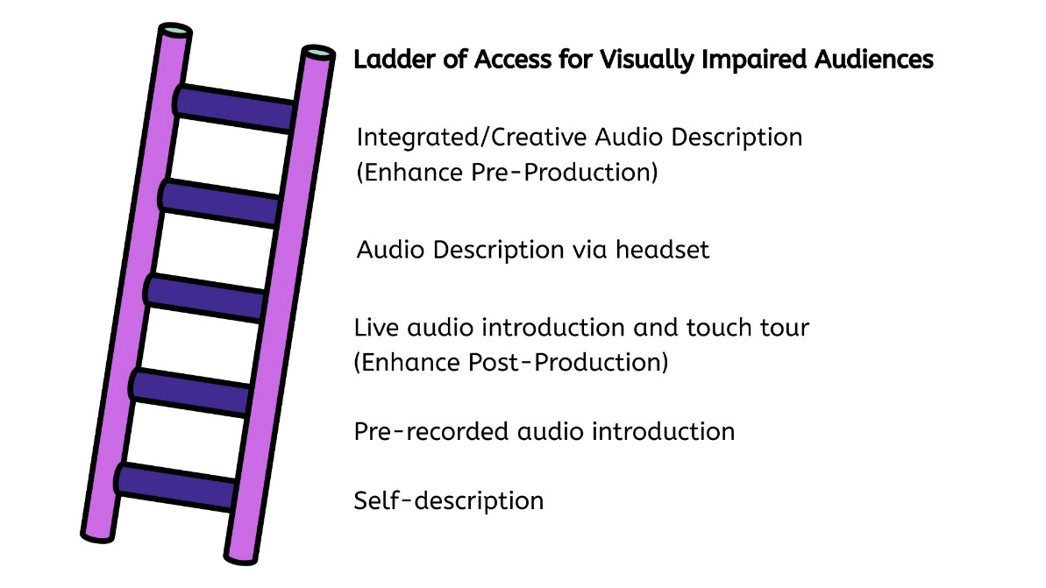

Infographic ALT text: A cartoon purple ladder with indigo rungs leans towards a list written in black text. There is a heading in bold font: Ladder of Access for Visually Impaired Audiences, then below, the list reads:

Integrated/Creative Audio Description (Enhance Pre-Production)
Audio Description via headset
Live audio introduction and touch tour (Enhance Post-Production)
Pre-recorded audio introduction
Self-description

‘DIY’ Options for Visually Impaired Access

These access offers can be created with minimal resources before or during the festival.

Self-description
Simple audio description given in the first person, where an individual provides clear and truthful visual information about themself, such as physical characteristics or clothing.

Suitable for: shows with very simple staging, such as stand-up, storytelling or 1-person shows. It could be done live or pre-recorded as an introduction at the start of the show.

Resources needed: small time commitment to prepare

Extant guide to self description available here: Self Description Guide with images.docx

Pre-recorded audio introduction
A brief (usually 5-10 minute) introduction to the visual elements of your show, such as set, costumes and visual language. This is usually pre-recorded and made available to audience members via the show’s web page and/or emailed to customers alongside ticket information.

Suitable for: low- or no-budget shows.

Resources needed: time commitment (approximately 1-2 hours)

Information about how to create an audio introduction is given on Page 5, or you can find an example of a pre-recorded audio introduction here:
https://youtu.be/Oc2NVmSNMKY?si=81fI5yRAMbYd_nLY

Other Options for Visually Impaired Access

These access offers require a greater commitment of time and resources, including costs, so need to be factored into thinking and planning ahead of the festival.

Live audio introduction and touch tour (Enhance Post-Production)
Bespoke service pioneered by Extant, where a visually impaired facilitator works alongside the artist or company to create a live audio introduction and 30 minute touch tour, which is then delivered pre-show by a company member (eg. Actors, SM, Producer or Director). The service includes training sessions in visual impairment awareness and touch tour delivery. Once created, the “Enhanced” show can then be carried out at any/all performances including touring, dependent on company and venue availability.

Suitable for: all types of show.

Resources needed: time commitment of 2 x half-days’ training plus up to 8 hours communication and administration.

More information and costings available from Extant at:
https://extant.org.uk/access/productions-enhance

Audio Description via headset
A trained audio describer either watches a recording of the show, attends dress rehearsal or a show performance in order to write the audio description script. They perform a live audio description speaking into a microphone, which visually impaired audience members listen to via headsets.

Suitable for: all types of show.

Resources needed: up to 1-2 hours’ communication and administration, plus Audio Describer fee and equipment hire. Many Edinburgh Fringe venues offer subsidised audio description.

Further information about audio description: https://www.rnib.org.uk/living-with-sight-loss/assistive-aids-and-technology/tv-audio-and-gaming/audio-description-ad/

Integrated/Creative Audio Description (Enhance Pre-Production)
A visually impaired facilitator works with the creative team to tailor creative ways to integrate and embed visual impairment access ideas (audio description or other aesthetic access) into the production process, design or script, starting from early-stage conversations about production themes and discussing examples of previous integrated access. The facilitator would feedback at R&D or early rehearsal stage on developing ideas and then attend a final sharing which takes place usually just before the production opens.

Suitable for: shows that are able to start integrating access at creation stage.

Resources needed: minimum of 5 rehearsal days, usually spread over the creation process. Sufficient time needs to be considered when working with integrated access to ensure that it is fully embedded in the process and final production from start to finish.

Please contact admin@extant.org.uk for more information, including costings, or visit https://extant.org.uk/access/productions-enhance

Guide to Creating an Audio Introduction

An audio introduction is a summary of visual information about your show, which can be delivered to the audience before they attend the performance, either live or more often pre-recorded. Audio introductions usually last between 5 to 10 minutes, depending on the complexity of the show, and describe elements including the staging, performers, costumes, and any key movement or visual themes.

In order to create an audio introduction for your show, the first thing to do is consider what you already know about the visual elements of the performance in order to help you write a script. You will have made creative choices about costumes, props and staging, and can use all of this existing knowledge to help you write the audio introduction.

It helps to follow a logical structure to help the audience follow and build up a picture of the show, for example you might structure your script as follows:

- Introduction: introduce the name of your show, and give any key information such as setting or genre.
- The theatre and stage: what kind of space is the performance taking place in, the stage dimensions, audience configuration, entrance and exit points.
- Character and costume descriptions: how many actors are there, what do they wear, do they play the same role throughout or is there multi-rolling?
- Staging, scenery and props: what does the stage look like, what objects do the characters interact with, and are there any other visual staging elements like video or film used in the show?
- Dance, movement sections and visual set-pieces: try to include a description of any sections that rely on visual cues and are not verbally explained within the performance. It can help to link these to sounds cues, such as the style of dancing carried out when a particular piece of music plays, or let the audience know that a particular image appears when the performer mentions a key phrase.

Remember that one of the main goals of any audio description is to help visually impaired audiences experience the show on an equitable footing with sighted audiences. Think about any moments in your show where the sighted audience will have a ‘gotcha’ moment, such as visual gags, and try to include these in your audio introduction if possible. There’s nothing worse for a visually impaired audience member than feeling left out of the joke when everyone around you is laughing at a funny visual.

You might also want to warn the audience about any interaction or use of gunshots, pyrotechnics etc., so they can be mentally prepared. Guide dogs can be disturbed by loud noises, and bright lights shone directly into the audience can trigger certain visual impairments, so it’s good to give people warning of anything that might adversely affect them.

Please note that, if possible, shows with an Audio Introduction should consider any ways to incorporate light-touch additions or changes that could be made within the show to make it more accessible for visually impaired audience members.

Distributing your Audio Introduction

Once your script is written, you should record it – ideally get your performers to perform it in character so the audience becomes familiar with the voices used in the show.

Then the final step is to distribute the recording to audience members, usually done in conjunction with your venue. We have included checklists below that we encourage artists and venues to follow in order to help reach visually impaired audience members.

Artist checklist:
- Upload your Audio Introduction recording to a free hosting service such as YouTube or Soundcloud
- Send the link for your Audio Introduction to your venue contact, and ask them to embed it on your show’s web page, and include it when emailing ticket information to customers
- Ensure your access information including the Audio Introduction link are updated with Fringe Society to include on their Access Listings.
- Include information about your accessible performances on all your marketing material, make sure your materials are available in accessible formats such as plain text, and include ALT text for all images.

Venue checklist:
- Have a clear process for uploading Audio Introduction links to the show’s web page, and ideally have an Access Listings page on your website where visually impaired customers can find out about all upcoming accessible shows
- Send the Audio Introduction link to all customers by email alongside ticket information. Audio Introductions can benefit other customers besides visually impaired people, such as people with anxiety or neurodivergent audience members. It also helps to raise awareness of access options with a wider audience.
- Create and print out a QR code for the Audio Introduction and have it available on the door at the show, in case audience members did not have the opportunity to listen to the Audio Introduction ahead of time.
- Ensure Front of House staff are briefed in supporting visually impaired audience members, including supporting people to scan the QR code, and using location-specific language such as ‘to the right’, rather than non-specific phrasing like ‘over there’, to help people navigate.

This Guide to Access for Visually Impaired Audiences at Edinburgh Festival Fringe was created for Extant by Louisa Sanfey, Artist Development Manager, February 2026.

If you’d like to learn more about Extant, or keep in touch with our work, please visit www.extant.org.uk

