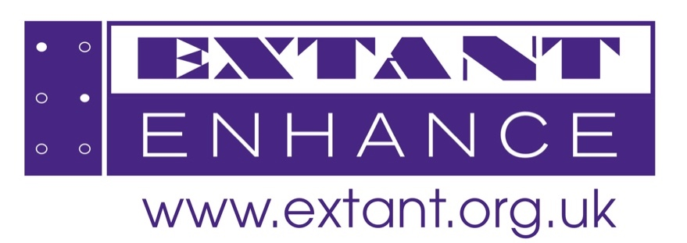
Image description: Purple Extant Enhance logo on a white background
How’s Your Head
Programme Notes
Introduction
Hello and welcome to this presentation of programme notes and touch tour for my show ‘How’s your head’ that has been developed alongside Extant as part of their Enhance Programme.
My name is Aarian Mehrabani and I am a 6 ft middle eastern man with thick black hair and shaved face, wearing an orange button down top tucked into black jeans. I am an actor, Comedian, writer
I am also blind and I have integrated audio description into the show, so there shouldn't be any elements that are purely visual but this is an opportunity to get a visual flavour and meet me!!
How's your head is my debut stand up show that draws on my personal experiences, relationships, health and identity. As such, although I may play around, altering my voice, mimicking, my voice is the only one you will hear throughout the show.
PRE SET
As with most traditional stand up shows, the staging is minimalistic consisting of…
- A black mic with an orange lead on a stand (placed centre stage.)
- A projector screen back wall
- There is a small table to the side of the stage with an orange table cloth and on it a glass of water bottles and a felt orange prop box
At this point the screen displays orange text that reads “Aarian Mehrabani How's your head” this is used throughout the show as a backdrop.
The audience is seated in a horse shoe around the small stage.
Key Visual Elements
After the announcement at the start, Aarian energetically enters, stands centre stage and grabs the mic from the stand. From that moment onwards he manoeuvres around the stage, sometimes pacing, sometimes rooted to the spot.
The first thing talked about is a fake show, when I tell you about this I will show a poster behind me.
There's a point in the show where I talk about a carton of eggs which I will pass round now.
When I ask audience members to name any object, I lean towards them offering the mic.
When I discuss mothers spotting a new catalogue I crouch and stare intensely to the side like an animal spotting it's prey.
When I mimic my mother talking, I crouch down as if talking to a child in front of her.
When I mention presenting in the style of a 50 year old businessman, I place the mic back on the stand, take an upright stance and don a cheap moustache.
Whilst presenting there are slides that headline the points I'm discussing. Upon completing the presentation, I turn to the rear wall, remove the moustache, retrieve the mic from the stand and resume in my normal presenting style.
When a hockey team picture is mentioned an image appears on the screen showing a team photograph. Three rows of 12 year boys all are white bar Aarian, on the front row are 7 boys who are seated with their legs spread wide, except for one whose knees are together.
Another image later appears on the screen showing a selfie of an 18 year old Aarian and Danny in a bar sipping cocktails.
When I discuss family and friends saying “Doodool Talla” I look down as if talking to young children and later rock arms as if holding a baby.
Accompanying the siren police lights flash.
When I describe Jack in the film Titanic, I lean forward as though I'm Jack gripping onto the door
When talking about Elmer the elephant, I return to the presentation style donning the cheap moustache.
As I summarise the story of Elmer the Elephant, slides appear on the screen displaying pages from the book. The title page is Elmer who is an Elephant with multi coloured patchwork skin.
At the end of this section I take off the moustache
There is then a section where I play voice recordings. The screen behind me displays a list of the recordings with the dates. The recording that we hear is dated October 10th 2023
When I mention an espresso cup, I pull out a grey mug that has a US flag on it and says hashtag ‘never forget’
When you hear this impact sound, there is a sudden blackout and as then the lights fade back up
When I say I've brought a bell I'll take it from the props box.
When I ring the bell, the lights snap to black and this is the end of the show.
Creative team:
Lead artist: Aarian Mehrabani
Artist support: Leah Eddleston
Enhance team:
Enhance facilitator: Anthony Gough
Enhance access worker: Ella Holappa
Enhance Training Manager: Caroline Jeyaratnam-Joyner

