A purple Extant logo
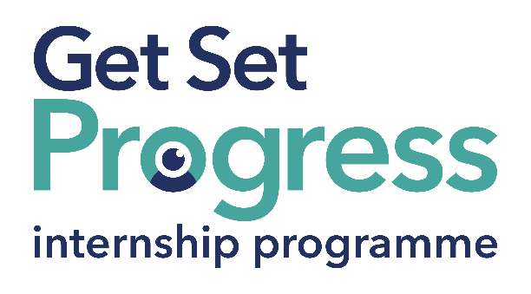

# Thinker-in-Residence (Internship)

Thomas Pocklington Trust and RNIB are collaborating with organisations to create new opportunities for blind and partially sighted people to find employment through the Get Set Progress Internship programme.

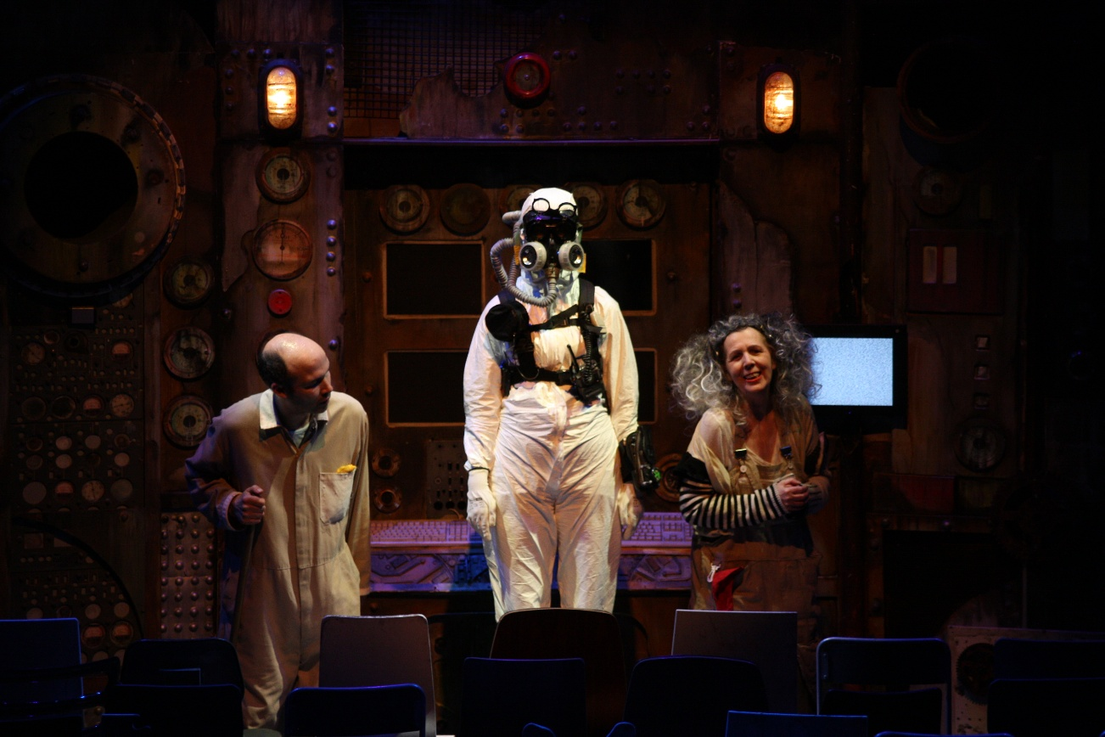

The Chairs, Extant Production 2016, Stratford Circus Arts Centre, Photography by Jack Townsend.

**Contents**

Thinker-in-Residence (Internship) 1

Join us at Extant 3

About Extant 5

Evolve 5

Artist Development 7

Audiences and Access 9

Participation 10

Current Team 11

What are the benefits of a Get Set Progress internship for me? 12

Key Information 14

Job Specification Information 16

Person specification 21

Essential criteria 22

What to do next? 24

Next Steps 27

# Join us at Extant

Extant is delighted to be offering a Thinker-in-Residence (Internship) as part of the Get Set Progress scheme.

Extant is the UK’s leading professional performing arts company that explores visual impairment to create unique and innovative artistic experiences, placing visually impaired people at the centre of all it does: from the productions we create, to the artists we support, to the audiences we perform to and the participants we work with. Extant is an award-winning company and are funded by Arts Council England as a National Portfolio Organisation as well as several trusts and foundations.

Since our inception in 1997 we have produced 8 ground-breaking national/international theatre productions led by visually impaired artists, including pioneering work on 3 site-specific and multi-sensory productions. We have developed 11 visually impaired-led Associate Artist productions since 2016, and our pioneering Pathways programme was the first programme in the UK to support emerging visually impaired artists. We have supported the career development of over 250 visually impaired artists, and our ongoing programme of training, participation and access consultancy provides a 360 approach of interlinked activity for visually impaired participants, audiences and artists.

## About Extant

Our present focus sits across four areas of work:

## Evolve

Since 2023 Extant has deliberately taken a pause on producing large scale touring productions to focus instead on Evolve. Our Founder, Artistic Director and CEO Maria Oshodi will be leaving the company in 2026/27 after over 25 years in post. Instead of carrying out a standard recruitment process, we are embarking on a four-year project to turn ourselves inside out, invite new disabled leaders into the heart of the company, share what we have learnt so far, and discover the new shape of Extant’s leadership together.

With full support from Arts Council England this programme will include:

1) Professional development and training for two visually impaired Trainee Artistic Directors who will work with Extant for 15 months and be involved in strategic decisions, be supported to produce their own public-facing project and embark on a bespoke journey of training and mentoring.

2) Links with Higher Education including Maria undertaking a PhD by public works on the history of Extant and key productions from our archive in relation to inclusive/innovative practice.

3) Working with multiple external facilitators to evaluate and reflect upon the internal processes of the company. This work includes board, staff, artists and participants and our aim is to embed learning and openness deep into the culture of Extant and to create systems that make our values sustainable and meaningful in everything we do.

## **Artist Development**

Extant has a rich history of supporting visually impaired creatives and are proud of our approach to developing artists, which is founded on principles of creating a safe, supported, accessible, and visually impaired-led environment. We have recently completed a 2-year pilot scheme funded by Esmee Fairbairn Foundation which enabled us to employ an Artist Development Manager (ADM) and pilot a new needs-led approach to working with visually impaired artists. The ADM role has been transformational for our visually impaired artist-community with visually impaired artists accessing valuable, person-centred support. Esmee Fairbairn Foundation have now committed to support a further 3-year period to continue the ADM role and employ a Trainee Creative Producer (TCP) to continue this nationally significant programme of work and employment opportunities for visually impaired creatives.

Here are some of the examples of recent Extant Associate Artist projects:  
  
[Unseen Audio Drama](https://extant.org.uk/productions/unseen)

[I Dream in Colour at Bloomsbury Festival](https://extant.org.uk/project/i-dream-in-colour)  
  
[Double Bill at Sprint Festival](https://extant.org.uk/project/extant-presents-no-future-i-dream-in-colour)

## Audiences and Access

In 2023, we launched a 3-year audience development programme called Enhance, supported by Paul Hamlyn Foundation, that aims to develop new visually impaired audiences for theatre by using low-fi tools, affordable techniques and training venues and companies in how to offer “Enhanced” shows as part of their programming and output. Over 3 years, Extant will be training 16 new visually impaired facilitators to deliver training to 72 sector partners to create over 150 “Enhanced” performances that will embed creative audio description, touch tours and visually impaired-friendly front of house practices.

## Participation

Supported by The Vision Foundation to expand our reach outside of London in 24/25, our two signature programmes Extant Theatre Club (a social group, focussed on visually impaired audience members attending high quality, accessible theatre) and No Dramas (drama improvisation workshops run by visually impaired arts professionals open to visually impaired adults with or without previous drama experience) will see Extant working with national partners to reduce isolation and build, joyous new communities that improve the social lives of visually impaired people.

Current Team

1 P/T (0.8) Visually impaired Artistic Director/CEO  
1 P/T (0.6) Visually impaired Trainee Artistic Director  
1 P/T (0.6) Visually impaired Trainee Creative Producer  
1 P/T (0.4) Visually impaired Projects Assistant (Intern)  
1 P/T (0.6) Operations Director  
1 P/T (0.6) Artist Development Manager  
1 P/T (0.6) Enhance Training Manager  
1 F/T Administrator and Projects Coordinator  
1 P/T (0.1) Book-keeper

## What are the benefits of a Get Set Progress internship for me?

As part of your 9-month internship, you will be part of a large cohort of fellow interns and gain the following:

* Obtain valuable work experience within the charity sector.
* Technology support (Including Microsoft Office) and upskilling opportunities.
* Online and in-person Training and development opportunities.
* Opportunity to present and network with Senior leaders within the Sight Loss Sector.
* Opportunities to build relationships with fellow interns.
* A personal mentor offering support, advice and guidance throughout your internship.
* Help deliver positive changes for people with sight loss.

As part of the GSP Internship programme, you will also be enrolled on the TPT [**Works For Me** **Employment Programme**,](https://www.pocklington.org.uk/employment/works-for-me-employment-programme/) where you will gain bespoke employment support, guidance and advice from the TPT Employment Team, some of the skills that you will receive support and guidance around include:

* CV writing
* Job searching
* Cover letter and speculative letter writing
* Application form writing
* Interview techniques
* The Works For Me team will also continue to support you in securing valuable employment once your time on the GSP internship programme has ended.

## **Key Information**

Role: Thinker-in-Residence (Internship)

Reporting to: Ian Abbott, Operations Director, Extant

Location: Hybrid / 2.06 Carlton Mansions, Brixton House, 385 Coldharbour Lane, London, SW9 8GL

Salary: £13.85 (p/h)

Hours: Fixed term 9-months. Full time – 37.5 hours per week. Whilst normal working hours will be Monday to Friday 9.00-5.30pm (with an hour break for lunch), this role will require flexibility with some evening and weekend working required. We operate a time off in lieu (TOIL) system.

Annual Leave: 20 days per annum plus bank/public holidays (pro rata).

Probation: Three months.

Notice Period: One month. One week during probationary period.

DBS: We will ask you to complete a DBS check, which will cover you to work with vulnerable groups.

Access: We can provide support for any access requirements you have.

Benefits:

* Tickets & travel expenses to see theatre.
* Contributory pension scheme.
* Employee assistance programme.

Closing Date: 10am, Wednesday 10th September 2025  
Interview Date: Wednesday 17th September 2025

Start Date: Monday 27th October 2025

## Job Specification Information

**Job purpose: Overview of the role**As part of its commitment to fostering innovative approaches and fresh ideas in visual impairment and the performing arts, Extant is excited to recruit its first visually impaired Thinker-in-Residence.

This role is designed to attract external expertise from different industries and offer valuable insight and critique into the organisation at a time when we are transitioning to a new leadership model and developing a new strategic focus. We welcome applications from people who may also be transitioning in their career and who may have engineered or been integral to moments of change strategically, operationally or personally. We want to ensure that Extant remains at the forefront of practice and thought leadership and our Thinker-in-Residence will be a critical part of that.

**Key areas of responsibility**

With a focus on being present in fields outside of the performing arts and identifying opportunities for us outside of our known world and limits, we’re excited to hear what insights the role will bring into the organisation which could affect, impact, change or revolutionise our existing programmes and projects.

There isn’t really a formal job description with a prescribed set of tasks or person specification, because we don’t know what will be different at the end of your time with us. We want to meet people who’re excited about this possibility, who want to ask questions, to gather new knowledge and share it back with us.

Some of the things you’ll do might include:

* Listening with intent
* Seeking significance
* Generating a professional inquiry
* Curating an intentional context
* Documenting, reflecting and sharing learning

Some of our key issues now are the hierarchy of access (as visual impairment is often at the bottom and ignored), innovative models of leadership and governance, the tension between AI and climate responsibility, the inaccessibility of archives, what does the future of audio description look like?

Some of the outputs you might deliver are:

* Rapid learning reports for internal and external usage
* A curated program of talks that link subject matter experts with industry changemakers
* Identifying new funding avenues or partner synergies outside of the performing arts

You’lldevelop an understanding of how a small arts organisation functions, how this role sits within it, how we are funded and attend regular team and project planning meetings.

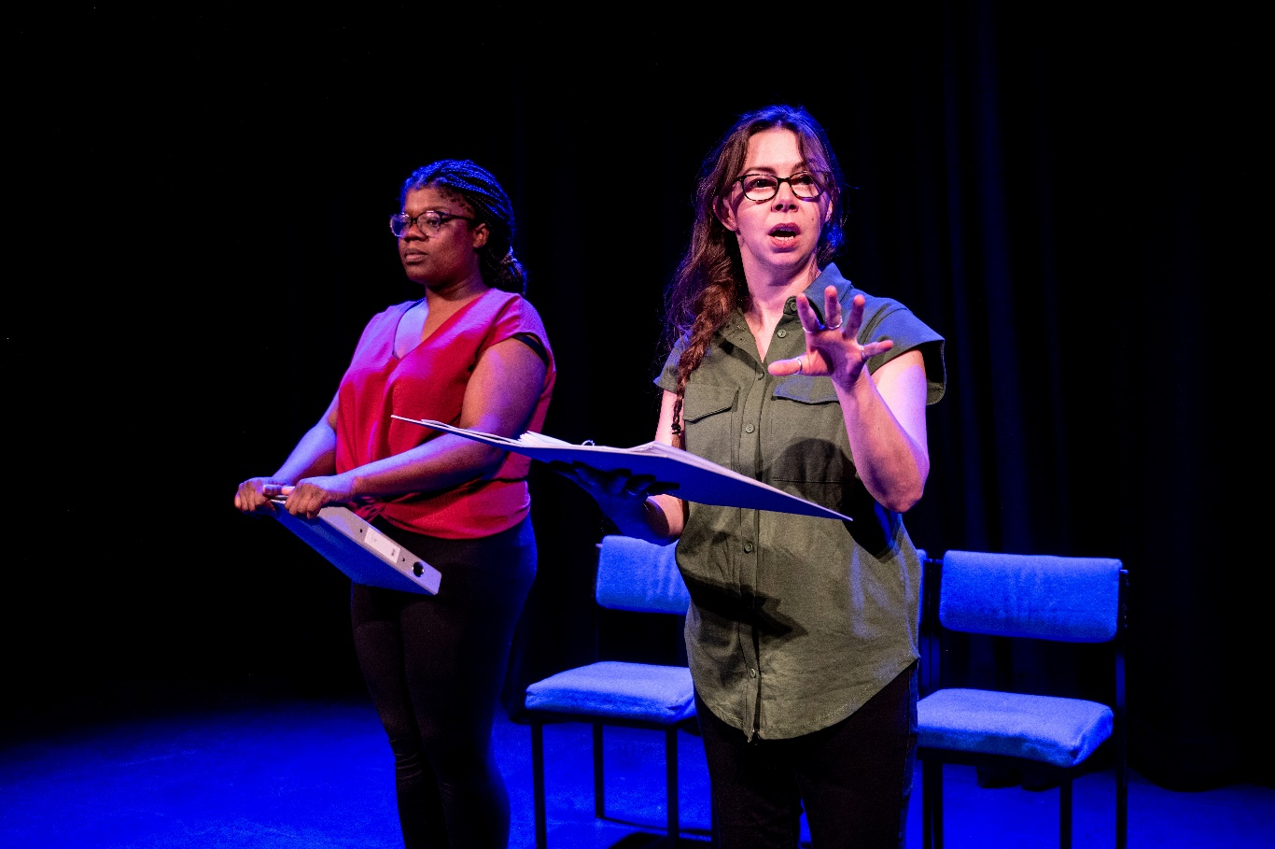

Unseen Tour, 2024. Photography credit: Graeme Braidwood.

## Person specification

The successful applicant will:

* be an imaginative, dynamic and articulate visually impaired person with experience of working outside of the performing arts
* be good at working together with people as well as being able to work well alone
* be generous spirited and have good communication skills
* have experience of organisational or personal change
* have enthusiasm, integrity and a curiosity to try new things
* have a strong interest and understanding of disability justice
* be able to demonstrate where you have worked collaboratively in a team to bring an idea to fruition and explain the role you played
* be willing to undertake an enhanced DBS check
* be happy to work in an office with a guide dog

## Essential criteria

* This post has a Genuine Occupational Requirement that the successful applicant be a person who is blind or partially sighted, in line with The Equality Act 2010
* We recognise that you may have faced barriers to training and gaining work experience and opportunities so we welcome applications from those who may not have taken a traditional route, are changing professions or who are coming to theatre later in life**.**
* You will be based in the UK. There are no relocation expenses for this role and would be expected to attend the Extant office at least once a month.
* You must be over 18 years of age, not in full or part-time education, and have a legal right to work in the UK.
* Willingness to travel to the TPT Hub in London for intern development events throughout the course of the internship programme (travel expenses will be covered by TPT).
* Have **not** previously undertaken the Get Set Progress internship programme.

## What to do next?

Please answer the following questions in a cover letter:

In answering these questions, think about the Job Description and Person Specification sections. **We’re interested in what you say rather than how you say it.** Soplease answer in a format that best suits you and enables you to respond fully to the questions. This could be written English, video, audio recording, bullet points, etc.

1. Let us know your:
   * Name
   * Pronouns (eg: she/her, he/him, they/them)
   * Address
   * Email
   * Contact Phone Number
   * Do you have the legal right to work in the UK?
   * Are you over 18?
   * This internship is for blind and partially sighted people. Please confirm that you have lived experience of sight loss.
2. Please tell us a little about your life and career journey so far. Why would this opportunity be the right next step for you? (write/record around 250 words)
3. What areas of the Thinker-in-Residence are particularly attractive to you? (write/record around 250 words)
4. Please tell us about any experience you have in working outside of the performing arts? (write/record around 250 words)
5. Thinking about your lived experience with sight loss, tell us about a time you experienced really good access and/or felt really welcomed into a space. (write/record around 250 words)
6. Tell us anything else you think will help us know more about you and your experience. (write/record around 250 words)
7. Please share any access requirements you have. Information you provide regarding your access requirements will not form part of the decision-making process.
8. Where did you hear about the Thinker-In-Residence role?

Send your answers in a cover letter to [ian@extant.org.uk](mailto:ian@extant.org.uk) alongside your CV by **10am on Wednesday 10th September 2025**. In the subject line put “Thinker-in-Residence Internship Application". If you are sending attachments, please send them as word documents and complete the monitoring form which can be found here.

We hope this pack has given you plenty of information before applying. But if you do have any further questions, please don’t hesitate to drop our Operations Director an email at [ian@extant.org.uk](mailto:ian@extant.org.uk) to arrange a chat before applying.

## **Next Steps**

* We are holding 1 x 1hr Zoom FAQ session at 11am on Monday 18th August where you will have a chance to ask our Trainee Artistic Director Tam Gilbert and Operations Director Ian Abbott any questions about the role. To attend the FAQ sessions please email [admin@extant.org.uk](mailto:admin@extant.org.uk) at least 48 hours before the session you would like to attend, and you’ll be sent the Zoom link.
* Deadline for applications – 10am on Wednesday 10th September 2025. If you are shortlisted for interview, you will hear from us by email or phone.
* The interviews will be held on the 17th September 2025. For the interviews, we will send you a list of questions in advance, so you have time to think about and prepare your answers.
* If you are not shortlisted for interview, we will let you know as soon as we can.
* The successful Thinker-in-Residence will start on Monday 27th October 2025.

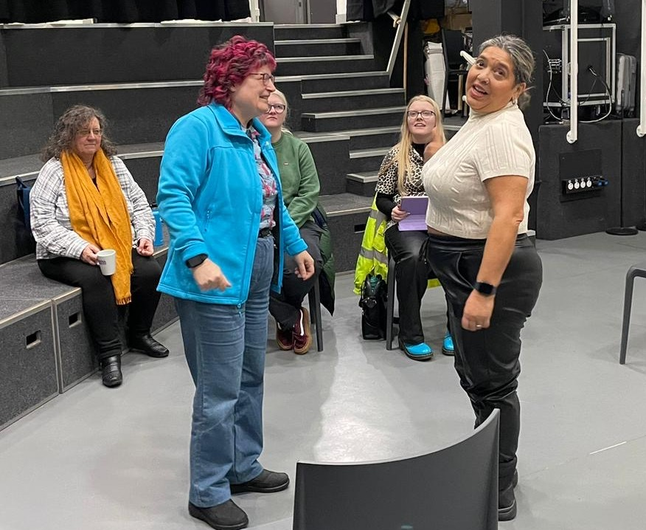

N

No Dramas, Arena Theatre, Wolverhampton, January 2025, Photograph by Phoebe Moore.