Purple Extant logo on a white background reads: 
Extant 
www.extant.org.uk

# Trainee Creative Producer

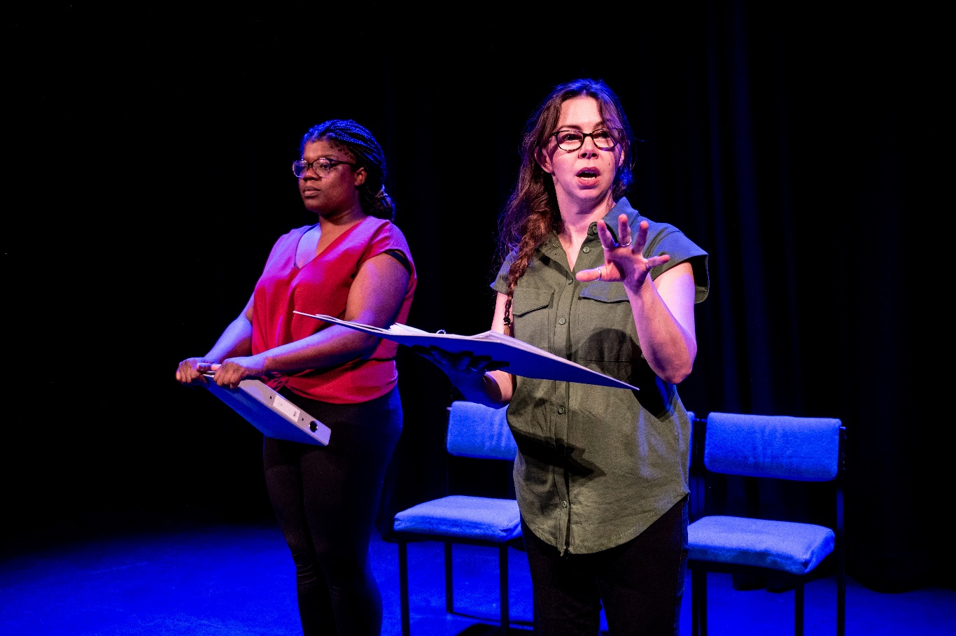

Unseen Tour, 2024. Photography credit: Graeme Braidwood.

Contents

Trainee Creative Producer 1

About Extant 2

Evolve 3

Artist Development 5

Audiences and Access 6

Participation 6

Current Team 7

Trainee Creative Producer (TCP) Role 8

Details 10

Person Specification 12

Probation and Notice 13

How to apply 13

About Extant

Extant is the UK’s leading professional performing arts company that explores visual impairment to create unique and innovative artistic experiences, placing visually impaired people at the centre of all it does: from the productions we create, to the artists we support, to the audiences we perform to and the participants we work with. Extant is an award-winning company and are funded by Arts Council England as a National Portfolio Organisation as well as several trusts and foundations.

Since our inception in 1997 we have produced 8 ground-breaking national/international theatre productions led by visually impaired artists, including pioneering work on 3 site-specific and multi-sensory productions. We have developed 11 visually impaired-led Associate Artist productions since 2016 and our pioneering Pathways programme was the first programme in   
the UK to support emerging visually impaired artists. We have supported the career development of over 250 visually impaired artists and our ongoing programme of training, participation and access consultancy provides a 360 approach of interlinked activity for visually impaired participants, audiences and artists.

Our present focus sits across four areas of work:

## Evolve

Since 2023 Extant has deliberately taken a pause on producing large scale touring productions to focus instead on Evolve. Our Founder, Artistic Director and CEO Maria Oshodi will be leaving the company in 2026/27 after over 25 years in post. Instead of carrying out a standard recruitment process, we are embarking on a four-year project to turn ourselves inside out, invite new disabled leaders into the heart of the company, share what we have learnt so far, and discover the new shape of Extant’s leadership together.

With full support from Arts Council England this programme will include:

1) Professional development and training for two visually impaired Trainee Artistic Directors who will work with Extant for 15 months and be involved in strategic decisions, be supported to produce their own public-facing project and embark on a bespoke journey of training and mentoring.

2) Links with Higher Education including Maria undertaking a PhD by public works on the history of Extant and key productions from our archive in relation to inclusive/innovative practice.

3) Working with multiple external facilitators to evaluate and reflect upon the internal processes of the company. This work includes board, staff, artists and participants and our aim is to embed learning and openness deep into the culture of Extant and to create systems that make our values sustainable and meaningful in everything we do.

## **Artist Development**

Extant has a rich history of supporting visually impaired creatives and are proud of our approach to developing artists, which is founded on principles of creating a safe, supported, accessible, and visually impaired-led environment. We have recently completed a 2-year pilot scheme funded by Esmee Fairbairn Foundation which enabled us to employ an Artist Development Manager (ADM) and pilot a new needs-led approach to working with visually impaired artists. The ADM role has been transformational for our visually impaired artist-community with visually impaired artists accessing valuable, person-centred support. Esmee Fairbairn Foundation have now committed to support a further 3-year period to continue the ADM role and employ a Trainee Creative Producer (TCP) to continue this nationally significant programme of work and employment opportunities for visually impaired creatives.

Here are some of the examples of recent Extant Associate Artist projects:  
  
[Unseen Audio Drama](https://extant.org.uk/productions/unseen)

[I Dream in Colour at Bloomsbury Festival](https://extant.org.uk/project/i-dream-in-colour)  
  
[Double Bill at Sprint Festival](https://extant.org.uk/project/extant-presents-no-future-i-dream-in-colour)

## Audiences and Access

In 2023, we launched a 3-year audience development programme called Enhance, supported by Paul Hamlyn Foundation, that aims to develop new visually impaired audiences for theatre by using low-fi tools, affordable techniques and training venues and companies in how to offer “Enhanced” shows as part of their programming and output. Over 3 years, Extant will be training 16 new visually impaired facilitators to deliver training to 72 sector partners to create over 150 “Enhanced” performances that will embed creative audio description, touch tours and visually impaired-friendly front of house practices.

## Participation

Supported by The Vision Foundation to expand our reach outside of London in 24/25, our two signature programmes Extant Theatre Club (a social group, focussed on visually impaired audience members attending high quality, accessible theatre) and No Dramas (drama improvisation workshops run by visually impaired arts professionals open to visually impaired adults with or without previous drama experience) will see Extant working with national partners to reduce isolation and build, joyous new communities that improve the social lives of visually impaired people.

# Current Team

1 P/T (0.8) Visually impaired Artistic Director/CEO  
1 P/T (0.6) Visually impaired Trainee Artistic Director  
1 P/T (0.6) Operations Director  
1 P/T (0.6) Artist Development Manager  
1 P/T (0.6) Enhance Training Manager  
1 F/T Administrator and Projects Coordinator  
1 P/T (0.1) Book-keeper

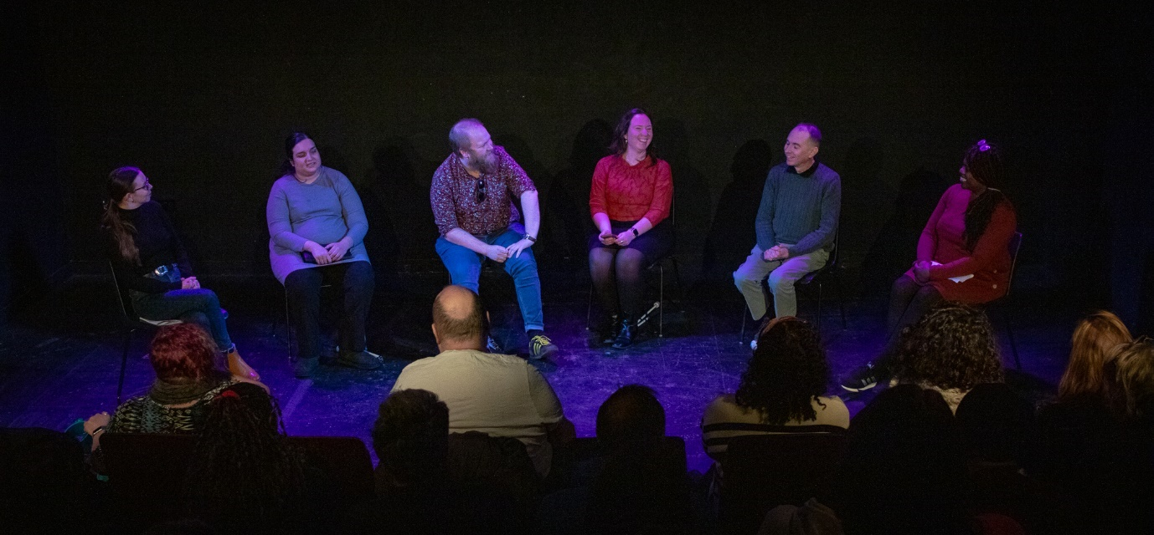

Unseen Live Event, February 2024. Photography credit: Jamie Dennis, Primo Digital Video Productions

# Trainee Creative Producer (TCP) Role

Start: May/June 2025, fixed term contract ending October 2027  
  
3 days per week (0.6 FTE)

Location: Hybrid - the TCP expected to be in the Extant office at Brixton House, London regularly to build relationships with Extant staff. We are open to supporting non-London based candidates to undertake the traineeship.

Responsible to: Artist Development Manager

Works closely with: Artistic Director/CEO, Operations Director, Trainee Artistic Director, the Board, and Administrator and Projects Coordinator

Salary and Benefits

* £30,000 per annum pro rata
* 20 days holiday plus 8 bank holidays per year pro rata (12 days and 4.8 days respectively)
* Occasional evening and weekend work will be required for which time off in lieu will be given
* Pension
* Employee Assistance Programme
* Training and Development Budget

# Details

Over the course of your time with the company, we will be flexible to try and accommodate any existing plans and projects that you have and may emerge.

During your time with us we will support you to:

* Develop, project manage and produce Extant projects, including Associate Artist projects.
* Support our artist development programme and other areas of our work.
* Enhance your skills in all elements of producing including fundraising, marketing and financial management, through a combination of mentoring and external training. Training programme will be agreed in line with the TCP’s individual training needs, but may include aspects such as industry landscape knowledge, networking, contracts and negotiation, leadership skills, understanding the creation process, scheduling, communication and audience development.
* Contribute to Evolve and engage in the internal operations of Extant.
* Represent the company at meetings and events.

As part of your induction, you will receive detailed information which explains how Extant works, our systems, processes and timelines. You will be encouraged to make your own decisions whilst learning the values, scale and parameters within which a company like Extant operates.

You will have access to all levels of Extant business to aid your learning from the artistic, operations, governance and major funding relationships. Although you will be involved in much of the company delivery, the incumbent Extant senior management team will still ultimately be responsible for key decision making to keep the right balance and support in place.

Although you will be line managed by the Artist Development Manager, there is additional support from the Operations Director. At the start of the role, you will collaborate in creating your work-plan, where expectations, objectives, roles and responsibilities will be agreed. An appraisal of agreed tasks will formulate your on-going monitoring.

# Person Specification

Our Trainee Creative Producer will be an imaginative, highly organised, dynamic and articulate visually impaired person with experience of working in the performing arts.

* You will have experience of delivering creative projects with different stakeholders
* You will be able to present persuasive ideas in excellent verbal and written ways and demonstrate ways of adapting your ideas
* You will have experience of administration, project development, fundraising and financial management
* You will have experience of writing and developing marketing strategy and copy for projects
* You will have a strong interest/understanding of the arts and disability scene
* You will be able to demonstrate where you have worked collaboratively in a team to bring an idea to fruition and explain the role you played
* You will be willing to undertake an enhanced DBS check
* You will be happy to work in an office with a guide dog.

# Probation and Notice

* 3-month probation period
* One month notice on either side during the probation period, 2 months thereafter.

# How to apply

This is a national call out to visually impaired people working in the performing arts who live in the UK and have the right to work here.

We are holding two x 1hr Zoom FAQ sessions where you will have a chance to ask our CEO/AD Maria Oshodi, Artist Development Manager Louisa Sanfey and Administrator and Projects Coordinator Ellen Jupp any questions about the role.

FAQ 1: 1pm Tuesday 28 Jan 2025

FAQ 2: 1pm Monday 24 Feb 2025

To attend the FAQ sessions please email [admin@extant.org.uk](mailto:admin@extant.org.uk) at least 48 hours before the session you would like to attend, and you’ll be sent the Zoom link.

Please read this document and send a CV and Cover Letter (as word documents) to [ian@extant.org.uk](mailto:ian@extant.org.uk) of no more than 2 pages which demonstrates how you meet the person specification and includes answers to the following questions:  
  
Why is the TCP role right for you right now?

What excites you about the role?  
What can you bring to Extant?

Where did you hear about the TCP role?   
  
You can send us a video or audio recording of your CV and Cover Letter (no longer than 5 minutes per document) if you prefer.

Once you’ve submitted your application, please complete an equal opportunities monitoring form which can be found here: [www.surveymonkey.co.uk/r/ExtantEqualOpps](http://www.surveymonkey.co.uk/r/ExtantEqualOpps)   
  
Application Deadline – 5pm, Friday 21 March 2025  
  
Stage 1 Interviews – Online – 29 & 30 April 2025  
  
Stage 2 Interviews – In Person, London – 6 May 2025  
  
We have disabled people on our shortlisting and interview panel and will supply interview questions in advance for each interview stage. For Stage 2 candidates we can offer access and travel support if required.

Thank you for taking the time to read this information and for your interest in the role of Trainee Creative Producer at Extant.

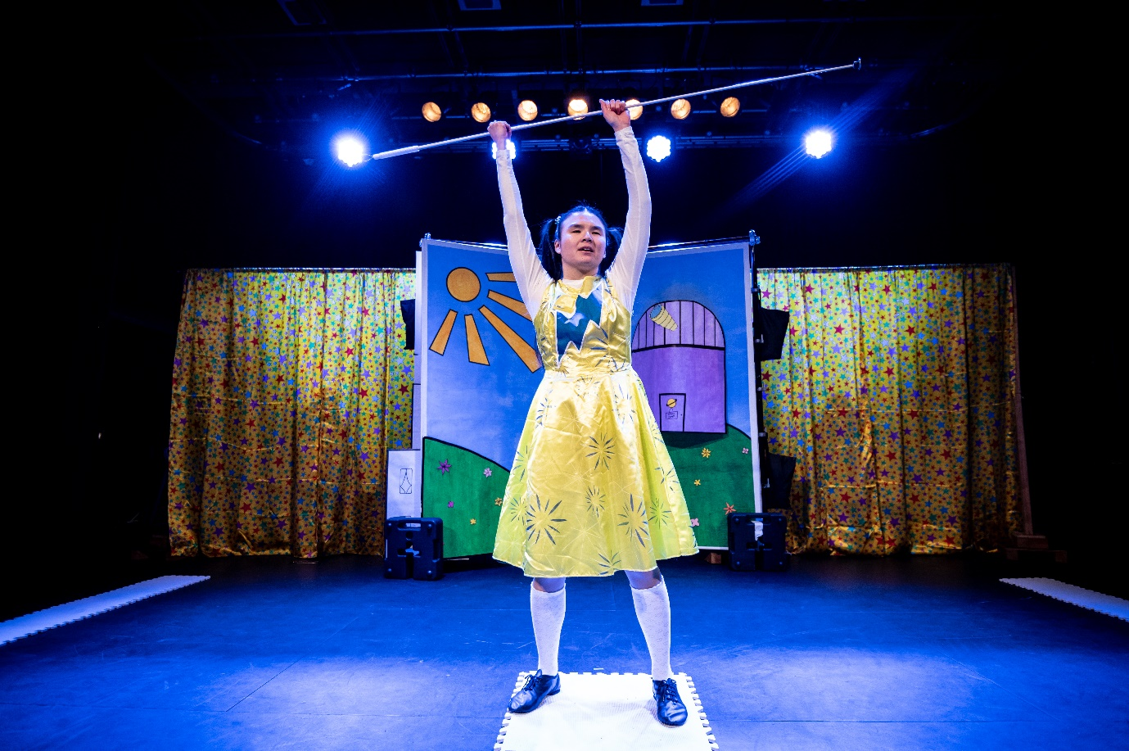

SuperPower Panto, March 2023. Photography credit: Graeme Braidwood.