Extant Trustee Recruitment Pack

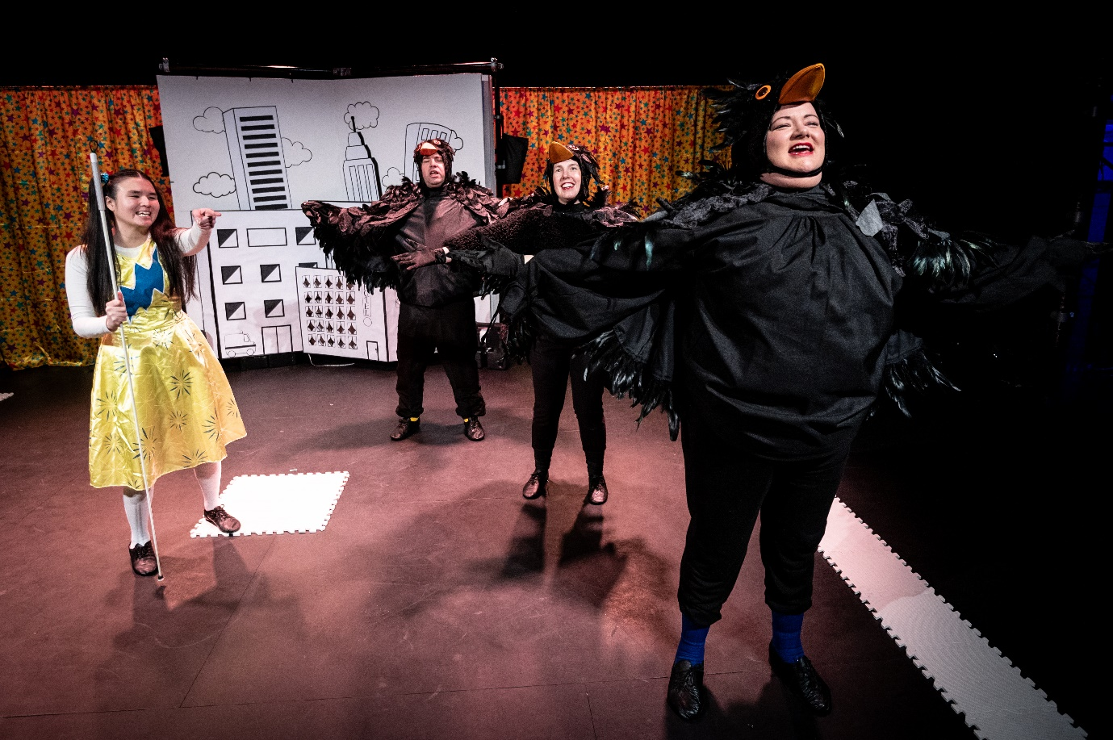

Super Power Panto, March 2023, Photo Credit: Graeme Braidwood.
Contents

Welcome from the Chair 2
About Extant 2
Role Summary - Trustee: 5
Person Specification 5
How To Apply 6

Welcome from the Chair

It has been my privilege to be Chair of Extant since 2018. To be involved in Extant is not just to be involved in an exciting theatre company, it is also to be part of the disability arts scene in the UK, representing an important piece of the landscape for disabled creatives and audiences, and for visually impaired (VI) people in particular.

As Chair, I have been part of conversations about art, the cultural sector, disability rights, and politics with a group of incredible artists, arts workers and fellow trustees. Together, we have supported Extant to respond to the impacts of Brexit, Covid, and economic recession. And, together, we have crafted plans for the future, including the upcoming retirement of our founding Artistic Director, which poses the question – what kind of leadership will come next?

In answer to this, we designed Evolve a three-year programme of research and development into arts leadership, which began in 2023. So far, there has been a lot to learn, to gather, and to reflect on; the next Chair of the Board and new trustees which we are recruiting will come in at a crucial point in this process. You will play a fundamental role in listening to and synthesizing some of the possible futures for Extant, turning ideas into realities.

I am proud of everything Extant has achieved during my tenure as Chair. I look forward to meeting other new trustees who cares as deeply as I do about Extant, our art, our communities, and our future.

Mary Paterson, outgoing Chair of the Board

About Extant
We are the UK’s leading professional performing arts company that explores visual impairment to create unique and innovative artistic experiences, placing visually impaired (VI) people at the centre of all we do: from the productions we create, to the artists we support, to the audiences we perform to and the participants we work with. We are funded by Arts Council England as a National Portfolio Organisation and receive additional funding from several trusts and foundations. In 2021 we won the P.K Walker Innovation in Craft Award for our work Flight Paths by Superfest Disability Film Festival.
Since our inception in 1997 we have produced 8 ground-breaking national/international theatre productions led by VI artists, including pioneering work on 3 site-specific and multi-sensory productions. We have developed 11 VI Associate Artist productions since 2016 and our pioneering Pathways programme was the first programme in the UK to support emerging VI artists. We have supported the career development of over 250 VI artists and our ongoing programme of training, participation and access consultancy provides a 360 approach of interlinked activity for VI participants, audiences and artists.

Our present areas of focus sit across four areas of work:
1. Evolve
Our Founder, Artistic Director and CEO Maria Oshodi will be leaving the company in 2026/27 after over 25 years in post. Instead of carrying out a standard recruitment process, we are embarking on a four-year project to turn ourselves inside out, invite new disabled leaders into the heart of the company, share what we have learnt so far, and discover the new shape of Extant’s leadership together.
With full support from Arts Council England this programme includes:

1) Professional development and training for VI Trainee Artistic Directors who each work with Extant for 15 months and are involved in strategic decisions, supported to produce their own public-facing work and experience a bespoke journey of training and mentoring.

2) Links with Higher Education including Maria undertaking a PhD by public works on the history of Extant and key productions from our archive in relation to inclusive/innovative practice.
3) Working with multiple external facilitators to evaluate and reflect upon the internal processes of the company. This work includes board, staff, artists and participants and our aim is to embed learning and openness deep into the culture of Extant and to create systems that make our values sustainable and meaningful in everything we do.
2. Artist Development
Extant has a rich history of supporting VI creatives and we are proud of our approach to developing artists, which is founded on principles of creating a safe, supported, accessible, and VI-led environment. We have recently completed a 2-year pilot scheme funded by Esmee Fairbairn Foundation which enabled us to employ an Artist Development Manager (ADM) and pilot a new needs-led approach to working with VI artists. The ADM role has been transformational for our VI artist-community with VI artists accessing valuable, person-centered support. We have been invited by Esmee Fairbairn Foundation to submit another application which builds on this work and creates a nationally significant programme of work and employment opportunities for VI creatives. We will hear the outcome in Summer 2024.
3. Audiences and Access
In 2023, we launched a 3-year audience development programme supported by Paul Hamlyn Foundation - Enhance aims to develop new VI audiences for theatre by using low-fi tools, affordable techniques and training venues and companies in how to offer “Enhanced” shows as part of their programming and output. Over 3 years, Extant will be training 16 new VI facilitators to deliver training to 72 sector partners to create over 150 “Enhanced” performances that will embed creative audio description, touch tours and VI-friendly front of house practices.

4. Participation
Supported by The Vision Foundation to expand our reach outside of London in 24/25, our two signature programmes Extant Theatre Club (a social group, focussed on VI audience members attending high quality, accessible theatre) and No Dramas (drama improvisation workshops run by VI arts professionals open to VI adults with or without previous drama experience) will see Extant working with national partners to reduce isolation and build joyous new communities that improve the social lives of VI people.

Current Team
1 P/T (0.8) VI Artistic Director/CEO
1 P/T (0.6) VI Trainee Artistic Director
1 P/T (0.6) Operations Director
1 P/T (0.6) Artist Development Manager
1 P/T (0.6) Enhance Training Manager
1 F/T Administrator and Projects Coordinator
1 P/T (0.1) Book-keeper
Additional Information About Our Recent Work
Link to Unseen audio drama
Link to blog from Maria about PhD
Link to blog from Ben about TAD

Link to Letter from Ben to Judi Dench

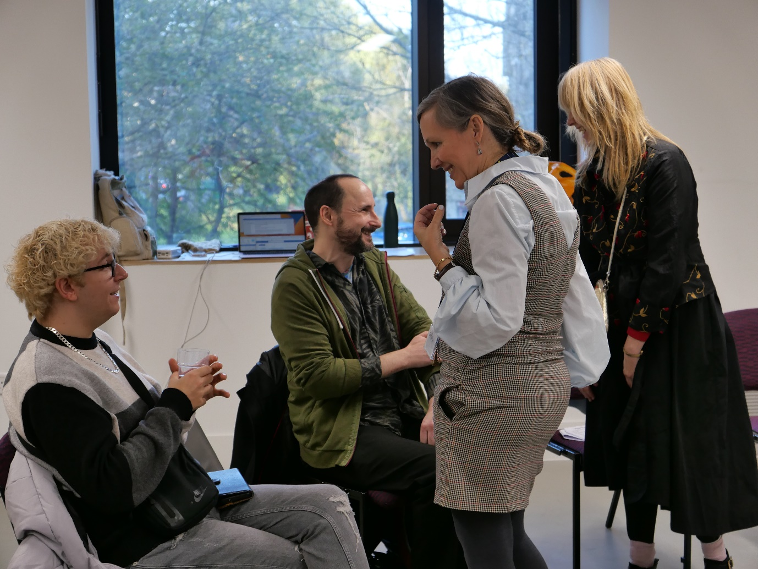
Enhance Training Day, November 2023, Photo Credit: Ian Abbott

Role Summary - Trustee:

We are looking for a number of Trustees to join our board; in particular, trustees with an interest in taking on the roles of Chair, Vice-Chair, NPO Sub-group Chair and treasurer at any time during their tenure. We currently have six trustees, of which 83% are female and 33% are visually impaired.

The Chair of the Board leads the governance team (board of Trustees) of this disability arts charity, supporting the Senior Leadership Team to fulfil our mission and vision offering support and (where appropriate) critical feedback to the staff, and representing the Charity to external stakeholders.

Trustees play a vital role in Extant. From ensuring our compliance with our governing document and charitable objectives, to scrutinising board papers, bringing their own expertise and perspective, leading discussions and being visible at Extant events and activities.

Person Specification

We are looking for people with experience of governance and leadership in any sector, who can chair meetings and get the best from a diverse group of trustees and staff members to provide strategic direction to Extant. Knowledge or experience of the governance requirements of a charity, particularly an Arts Council England National Portfolio Organisation, would be useful.

We are looking for people who are committed to the work and values of Extant, and who are prepared to and have the skills to support the staff team through a period of significant change.

Main Duties (Chair)

- Provide leadership to the Charity and its Board, ensuring the Charity works towards its mission and vision, and meets the requirements of its principal funders, including Arts Council England.
- Chair quarterly Board meetings and other sub group meetings where appropriate, working closely with the Senior Leadership Team to co-ordinate meetings and topics.
- Provide regular line management support to the CEO/ Artistic Director, and carry out annual appraisals.
- Manage, motivate, and develop the Board of Trustees, including annual appraisals and skills audits.
- Comply with funders’ requirements, including Arts Council England’s governance requirements for National Portfolio Organisations, and ensure that the governance arrangements are working in the most effective way for the Charity.
- Maintain close relationships with key funders and partners, including representing the Charity at external events.

Role Type
Voluntary with expenses reimbursed
Location
Board meetings take place via Zoom – so candidate can be based anywhere, with the expectation of attendance at our away day and company events which currently happen in London across England.

Benefits
Whilst we recognise that the role is voluntary, we believe there are several benefits to being an Extant trustee including:

- Help to contribute and improve the lives and community of disabled people by changing an ableist theatre industry in new and positive ways.
- Learn and enhance your own knowledge.
- Grow your network by meeting new people at our great events.
Time Commitment
Up to two days per month which includes: four evening board meetings, one annual away day, one review meeting with Arts Council England (chair only), two subgroup meetings

Terms of Office
Initial three years, ideally renewed for a second term to a total of six years
Timeline
10th July – Application Deadline
18th July – Interviews (Online)
w/b 4th November board meeting
w/b 20th January 2025 board meeting
How To Apply
Please send us your CV and a cover letter which outlines your relevant experience and interest in becoming a trustee and if you have an interest in taking on the roles of Chair, Vice-Chair, NPO Sub-group Chair or treasurer.

If you would like an informal chat or any other information regarding the role or organisation, please contact Ellen Jupp (admin@extant.org.uk) who will arrange a conversation with one of our trustees.
We’re happy to receive your application in a different format like an audio or video recording – please ensure that each document is no more than 5 minutes in length.
Your CV and covering letter should be sent to admin@extant.org.uk by 5pm, 10th July 2024.
Please include a completed Equal Opportunities Monitoring Form (available on our website) which will be kept securely and separate from your application.

