Trainee Artistic Director

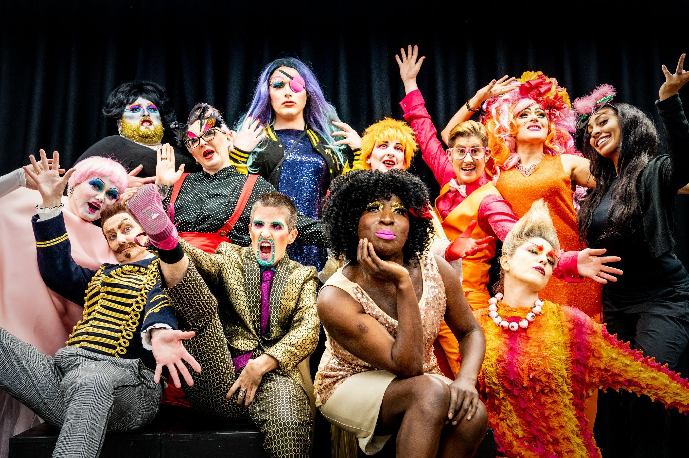
Quiplash: Unsightly Drag, 2019-20
Contents
Trainee Artistic Director 1
About Extant and Our Areas of Work 1
Trainee Artistic Director Role 4
Details 5
Person Specification 6
Probation and Notice 7
How to apply 7

About Extant
Extant is the UK’s leading professional performing arts company that explores visual impairment to create unique and innovative artistic experiences, placing visually impaired (VI) people at the centre of all it does: from the productions we create, to the artists we support, to the audiences we perform to and the participants we work with. Extant is an award-winning company and are funded by Arts Council England as a National Portfolio Organisation as well as several trusts and foundations.
Since our inception in 1997 we have produced 8 ground-breaking national/international theatre productions led by VI artists, including pioneering work on 3 site-specific and multi-sensory productions. We have developed 11 VI Associate Artist productions since 2016 and our pioneering Pathways programme was the first programme in the UK to support emerging VI artists. We have supported the career development of over 250 VI artists and our ongoing programme of training, participation and access consultancy provides a 360 approach of interlinked activity for VI participants, audiences and artists.
Our present focus sits across four areas of work:
Evolve

Our Founder, Artistic Director and CEO Maria Oshodi will be leaving the company in 2026/27 after over 25 years in post. Instead of carrying out a standard recruitment process, we are embarking on a four-year project to turn ourselves inside out, invite new disabled leaders into the heart of the company, share what we have learnt so far, and discover the new shape of Extant’s leadership together.
With full support from Arts Council England this programme will include:

1) Professional development and training for two VI Trainee Artistic Directors who will work with Extant for 15 months and be involved in strategic decisions, be supported to produce their own public-facing project and embark on a bespoke journey of training and mentoring.

2) Links with Higher Education including Maria undertaking a PhD by public works on the history of Extant and key productions from our archive in relation to inclusive/innovative practice.
3) Working with multiple external facilitators to evaluate and reflect upon the internal processes of the company. This work includes board, staff, artists and participants and our aim is to embed learning and openness deep into the culture of Extant and to create systems that make our values sustainable and meaningful in everything we do.
Artist Development
Extant has a rich history of supporting VI creatives and are proud of our approach to developing artists, which is founded on principles of creating a safe, supported, accessible, and VI-led environment. We have recently completed a 2-year pilot scheme funded by Esmee Fairbairn Foundation which enabled us to employ an Artist Development Manager (ADM) and pilot a new needs-led approach to working with VI artists. The ADM role has been transformational for our VI artist-community with VI artists accessing valuable, person-centered support. We have been invited by Esmee Fairbairn Foundation to submit another application which builds on this work and creates a nationally significant programme of work and employment opportunities for VI creatives. We will hear the outcome in Summer 2024.

Audiences and Access
In 2023, we launched a 3-year audience development programme supported by Paul Hamlyn Foundation - Enhance aims to develop new VI audiences for theatre by using low-fi tools, affordable techniques and training venues and companies in how to offer “Enhanced” shows as part of their programming and output. Over 3 years, Extant will be training 16 new VI facilitators to deliver training to 72 sector partners to create over 150 “Enhanced” performances that will embed creative audio description, touch tours and VI-friendly front of house practices.

Participation
Supported by The Vision Foundation to expand our reach outside of London in 24/25, our two signature programmes Extant Theatre Club (a social group, focussed on VI audience members attending high quality, accessible theatre) and No Dramas (drama improvisation workshops run by VI arts professionals open to VI adults with or without previous drama experience) will see Extant working with national partners to reduce isolation and build, joyous new communities that improve the social lives of VI people.

Current Team
1 P/T (0.8) VI Artistic Director/CEO
1 P/T (0.6) VI Trainee Artistic Director
1 P/T (0.6) Operations Director
1 P/T (0.6) Artist Development Manager
1 P/T (0.6) Enhance Training Manager
1 F/T Administrator and Projects Coordinator
1 P/T (0.1) Book-keeper

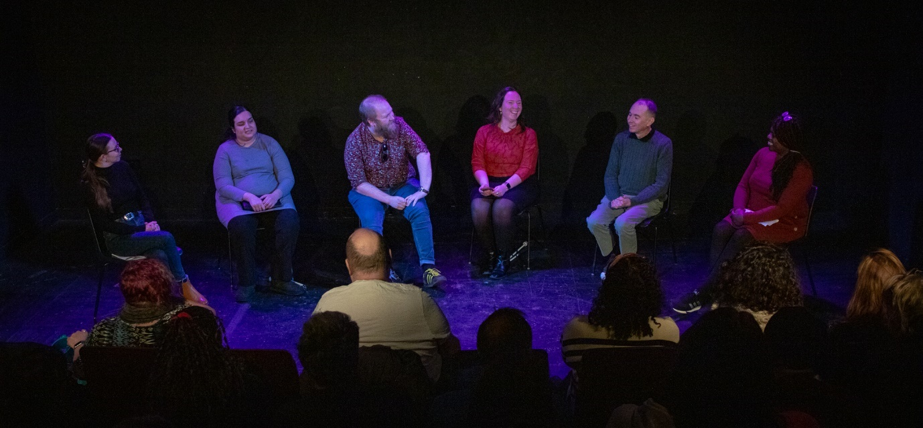

Unseen Live Event, February 2024, Photo credit: Jamie Dennis, Primo Digital Video Productions

Trainee Artistic Director Role

Start: Early December 2024, 15 months fixed term contract, ending February 2026
3 days per week (0.6 FTE)
Location: Hybrid - the TAD expected to be in the Extant office at Brixton House, London regularly (at least 2 days a month) to build relationships with Extant staff. We are open to supporting non-London based candidates to undertake the traineeship.
Responsible to: Artistic Director/CEO
Works closely with: Operations Director, the Board and Administrator and Projects Coordinator
Salary and Benefits

- £30,000 per annum pro rata
- 20 days holiday plus 8 bank holidays per year pro rata (12 days and 4.8 days respectively)
- Occasional evening and weekend work will be required for which time off in lieu will be given
- Pension
- Employee Assistance Programme
- Training and Development Budget
- Theatre Ticket Budget.

Details
Over the course of your 15 months with the company, we will be as flexible as we can to accommodate your existing plans and projects that may emerge during the traineeship.

During your time with us we will support you to:

- Develop your own creative project with a financial contribution of £10,000 from Extant alongside other resources
- Participate in external training delivered in areas such as governance, recruitment, producing and financial management
- Observe, engage in and contribute to the internal operations of Extant
- Work with the AD/CEO on creative access consultations with external stakeholders
- Join in and present at Extant board meetings and actively contribute to the Evolve programme
- Participate in our Paul Hamlyn Foundation funded programme Enhance
- Work alongside Extant to support our artist development programme
- Artistically lead on Extant initiated projects
- Receive mentorship from a disabled industry leader
- Write and revise company documents and policies
- Represent the company at external meetings and events
- Manage your own budget
As part of your induction, you will receive detailed information which explains how Extant works, our systems, processes and timelines. You will be encouraged to make your own decisions whilst learning the values, scale and parameters within which a company like Extant operates at.
You will have access to all levels of Extant business to aid your learning from the artistic, operations, governance and major funding relationships. Although you will be involved in much of the company delivery, the incumbent Extant senior management team will still ultimately be responsible for key decision making to keep the right balance and support in place.

Although you will be line managed by the AD/CEO, there is additional support from the Operations Director. At the start of the role, you will collaborate in creating your work-plan, where expectations, objectives, roles and responsibilities will be agreed. You’ll do your fair share of administration and project management as part of the role, and an appraisal of these tasks will formulate your on-going monitoring.

Here are some of the examples of what our first TAD has worked on and the reflections they’ve undertaken to date:
Unseen Audio Drama

Ben Wilson: My development as an artistic leader
Ben Wilson simmers over Richard III controversy

EastLondonLines Interview

Person Specification

Our Trainee Artistic Director will be an imaginative, dynamic and articulate visually impaired person with experience of working in the performing arts.

- You will have experience of delivering creative projects with different stakeholders
- You will be able to present persuasive ideas in excellent verbal and written ways and demonstrate ways of adapting your ideas
- You will have a strong interest/understanding of the arts and disability scene
- You will have experience in leading creative workshops accessibly
- You will be able to demonstrate where you have worked collaboratively in a team to bring an idea to fruition and explain the role you played
- You will have experience in critical thinking and forming innovative ideas
- You will have some experience of administration, project development and financial management
- You will have some experience of writing and developing marketing copy for projects
- You will be willing to undertake an enhanced DBS check
- You will be happy to work in an office with a guide dog.

Probation and Notice

- 3-month probation period
- One month notice on either side during the probation period, 2 months thereafter.

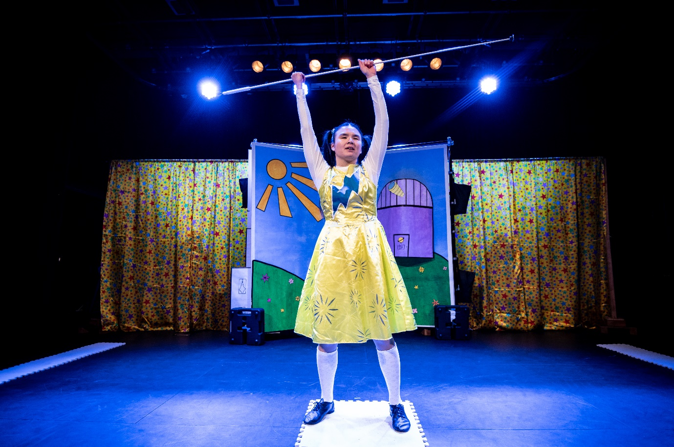

SuperPower Panto, March 2023, photo credit: Graeme Braidwood

How to apply

This is a national call out to visually impaired people working in the performing arts who live in the UK and have the right to work here.

We are holding two x 1hr Zoom FAQ sessions where you will have a chance to ask our CEO/AD Maria Oshodi, current Trainee Artistic Director Ben Wilson and Administrator and Projects Coordinator Ellen Jupp any questions about the role.
FAQ 1: 4pm Wednesday June 12th 2024
FAQ 2: 11:30am Monday July 8th 2024
To attend the FAQ sessions please email admin@extant.org.uk at least 48 hours before the session you would like to attend, and you’ll be sent the Zoom link.

Please read this document and send a CV and Cover Letter (as word documents) to ian@extant.org.uk of no more than 2 pages which demonstrates how you meet the person specification and includes answers to the following questions:
Why is the TAD role right for you right now?
What excites you about the role?
What can you bring to Extant?
Where did you hear about the TAD role?
You can send us a video or audio recording of your CV and Cover Letter (no longer than 5 minutes per document) if you prefer.

Once you’ve submitted your application, please complete an equal opportunities monitoring form which can be found here: www.surveymonkey.co.uk/r/ExtantEqualOpps
Application Deadline – 10am, 16th August 2024
Stage 1 Interviews – Online, 10th and 11th September 2024
Stage 2 Interviews – In Person, London – 19th September 2024
We have disabled people on our shortlisting and interview panel and will supply interview questions in advance for each interview stage. For Stage 2 candidates we can offer access and travel support if required.
Thank you for taking the time to read this information and for your interest in the role of Trainee Artistic Director at Extant.

