If you require this pack in any other format such as large print, please contact admin@extant.org.uk or call 020 7820 3737 and we will be happy to send it to you.

Administrator and Projects Co-ordinator
Full time, permanent, flexible hybrid working, £26,000 per year

Arts Council England (ACE) has funded us as a National Portfolio Organisation (NPO) from 2023-26 to undertake a programme of radical transformation, exploring new ways to enable truly inclusive arts leadership in the future. Extant is seeking a confident, independent worker to provide ongoing company and project administrative support as we change and grow.

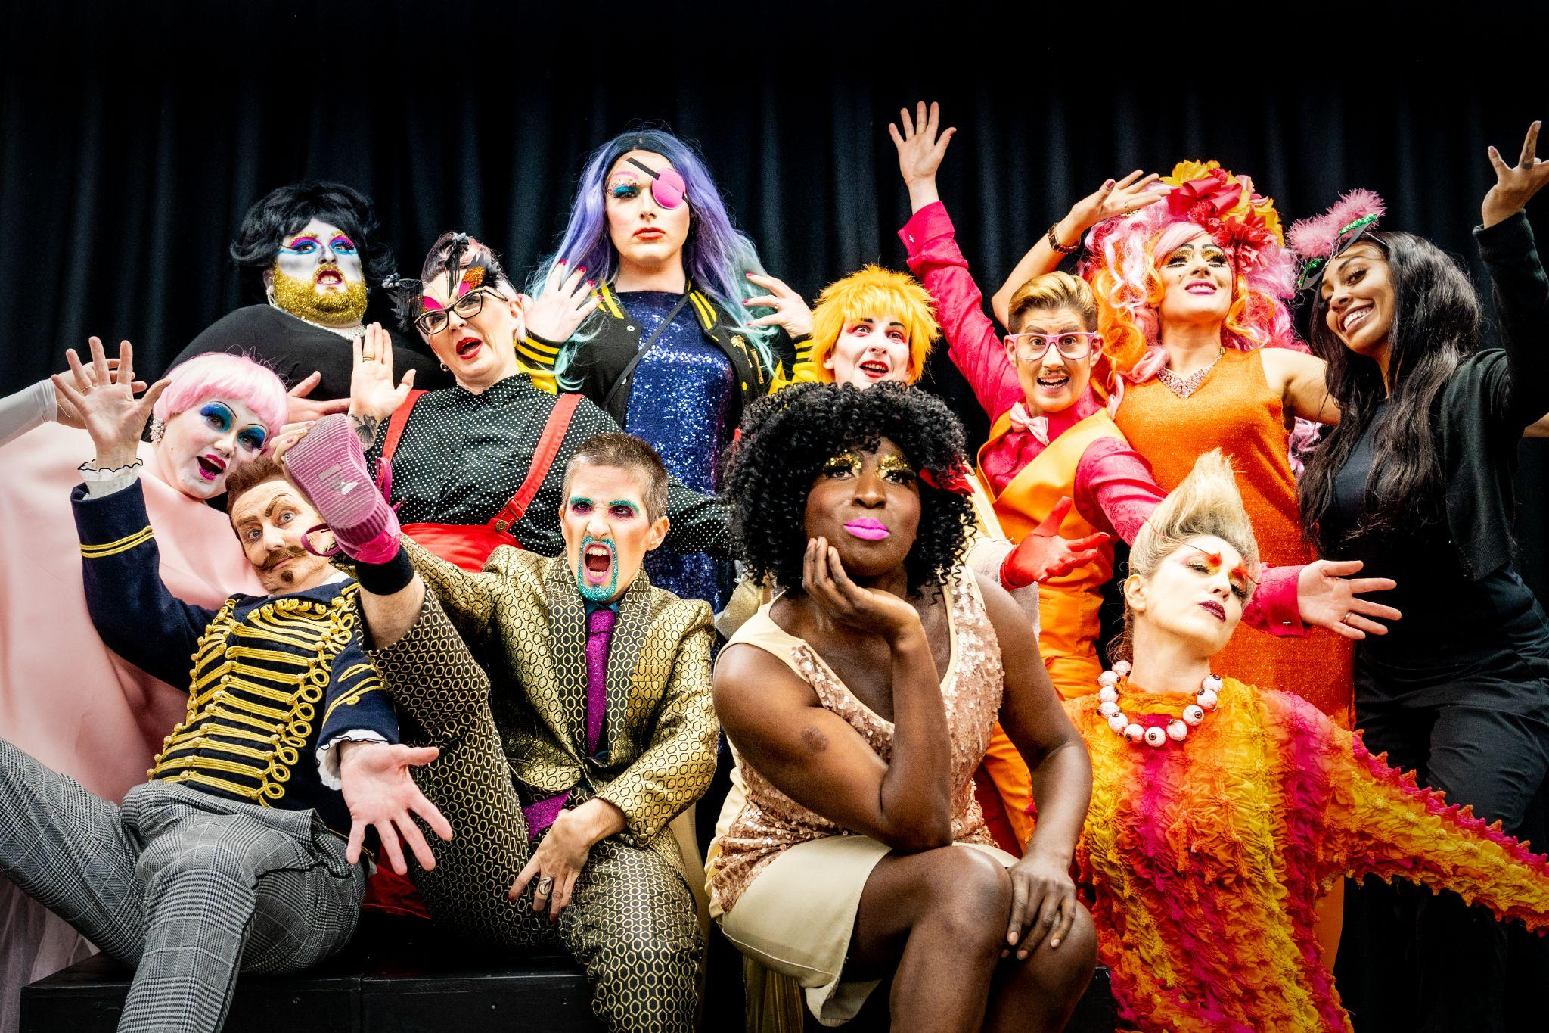
About Extant
Extant is the UK’s leading professional performing arts company that explores visual impairment to create unique and innovative artistic experiences, placing visually impaired people at the centre of all we do: from the productions we create, to the artists we employ or support to build stronger careers in the sector, to the audiences we perform to and the participants we work with.

In our company, visual impairment is celebrated as a rich source of creative engagement that inspires fresh perspectives.

We fulfil our purpose by:

- Demonstrating artistic excellence, professionalism, and high production values with the express inclusion of visually impaired (VI) performing artists
- Providing sustainable employment and supporting the professional development of visually impaired people working in the arts
- Putting the accessibility for visually impaired audiences at the centre of the artistic process
- Providing opportunities for visually impaired people to get involved in the arts for the first time.
- Ensuring that our company is led by visually impaired people, artistically, managerially and at board level.

Since 2007, we have delivered participatory projects for VI participants alongside professional theatre productions that feature VI artists and welcome VI audiences.
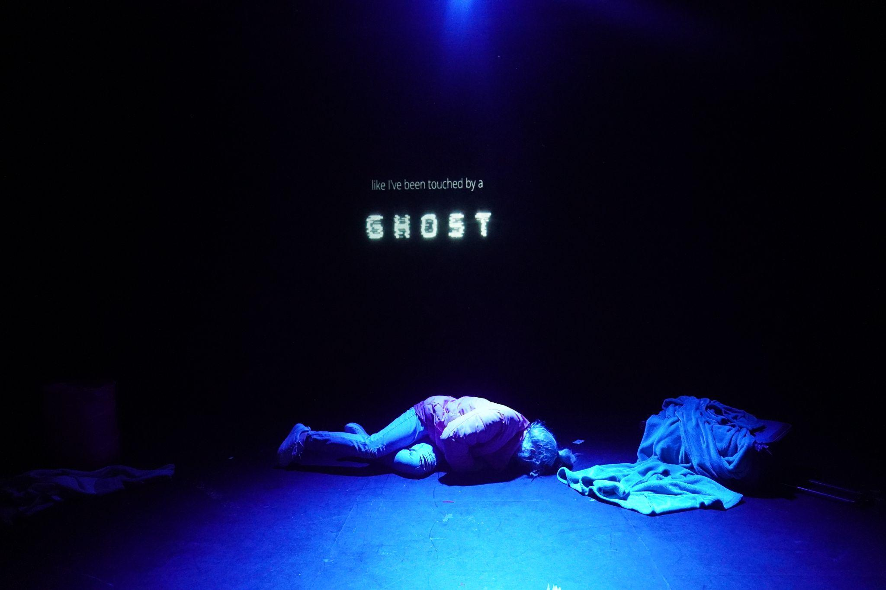

Administrator and Projects Co-ordinator

The Role
This is a vital role at the heart of all we do, supporting a team of staff who work remotely from across the UK, as well as freelancers and participants. The ideal candidate is a confident and organised independent worker, who shares our ideas and values.

We are offering the role as a full-time post with hybrid working at our office in Brixton, London. But if you think this job could work for you in a different way – for example as a flexible/ part-time and/or remote position – please send us a proposal and we would love to discuss your ideas.

The key responsibilities of this job include:
- Core administrative support to the company, its staff, freelancers and volunteers
- Servicing our board of Trustees
- Ongoing marketing and communication with our participants, our artists and through our public channels.

You will have an interest in the arts and disability, and an awareness (or desire to learn about) access needs for disabled people. You will want to be part of our journey of transformation, exploring new models of arts management and leadership for the future.

Job Conditions

This is a permanent, full-time contract of employment, 37 hours per week.*

Hours: Currently 37 hours per week. Some evening and weekend work required, for which time off in lieu is given.
Location: We offer hybrid working, including home and office-based working at our base in Brixton House, 2.06 Carlton Mansions, Brixton House, 385 Coldharbour Lane, London, SW9 8GL.
Responsible to: Operations Director
Salary: £26,000 per annum
Deadline for applications: 12 noon, Friday 6th October 2023
Interviews: Thursday 12th October 2023

*We welcome proposals for alternate ways of managing the role, including hybrid, remote and/or part time.

The Extant team

Artistic Director/CEO (0.8 FTE)
Director of Operations (0.6 FTE)
Artist Development Manager (0.6 FTE. fixed term until March 2024)
Trainee Artistic Directors (from July 2023, 0.6 FTE)
Administrator and Projects Co-ordinator (Full Time)
Bookkeeper (0.1 FTE)

Person Specification

Essential Skills and Experience

- At least one year’s experience in an administrative role (this could be in a voluntary position)
- Confident, independent worker with experience of managing your own time
- Good at communicating in person and in writing
- Competent in Microsoft packages including Word, Excel and Outlook

Desirable Skills and Experience

- Understanding of access issues for disabled people.
- Experience of financial administration and fundraising
- Experience updating websites using WordPress

The candidate must also:

- have the right to work in the UK.
- be willing to undertake an enhanced DBS check.
- be comfortable working in an environment where guide and other assistance dogs may be present.
- be willing to travel to different parts of the UK and a variety of venues

How to apply

Please send a cover letter (no more than 1000 words) and CV (no more than 2 sides of A4) in Microsoft Word Format to admin@extant.org.uk by 12 NOON ON FRIDAY 6TH OCTOBER 2023.

Interviews will be held on THURSDAY 12TH OCTOBER 2023 at the company base in Brixton House.

For an informal conversation about the role, please contact Hannah Farrell, the current postholder, via hannah.farrell@extant.org.uk

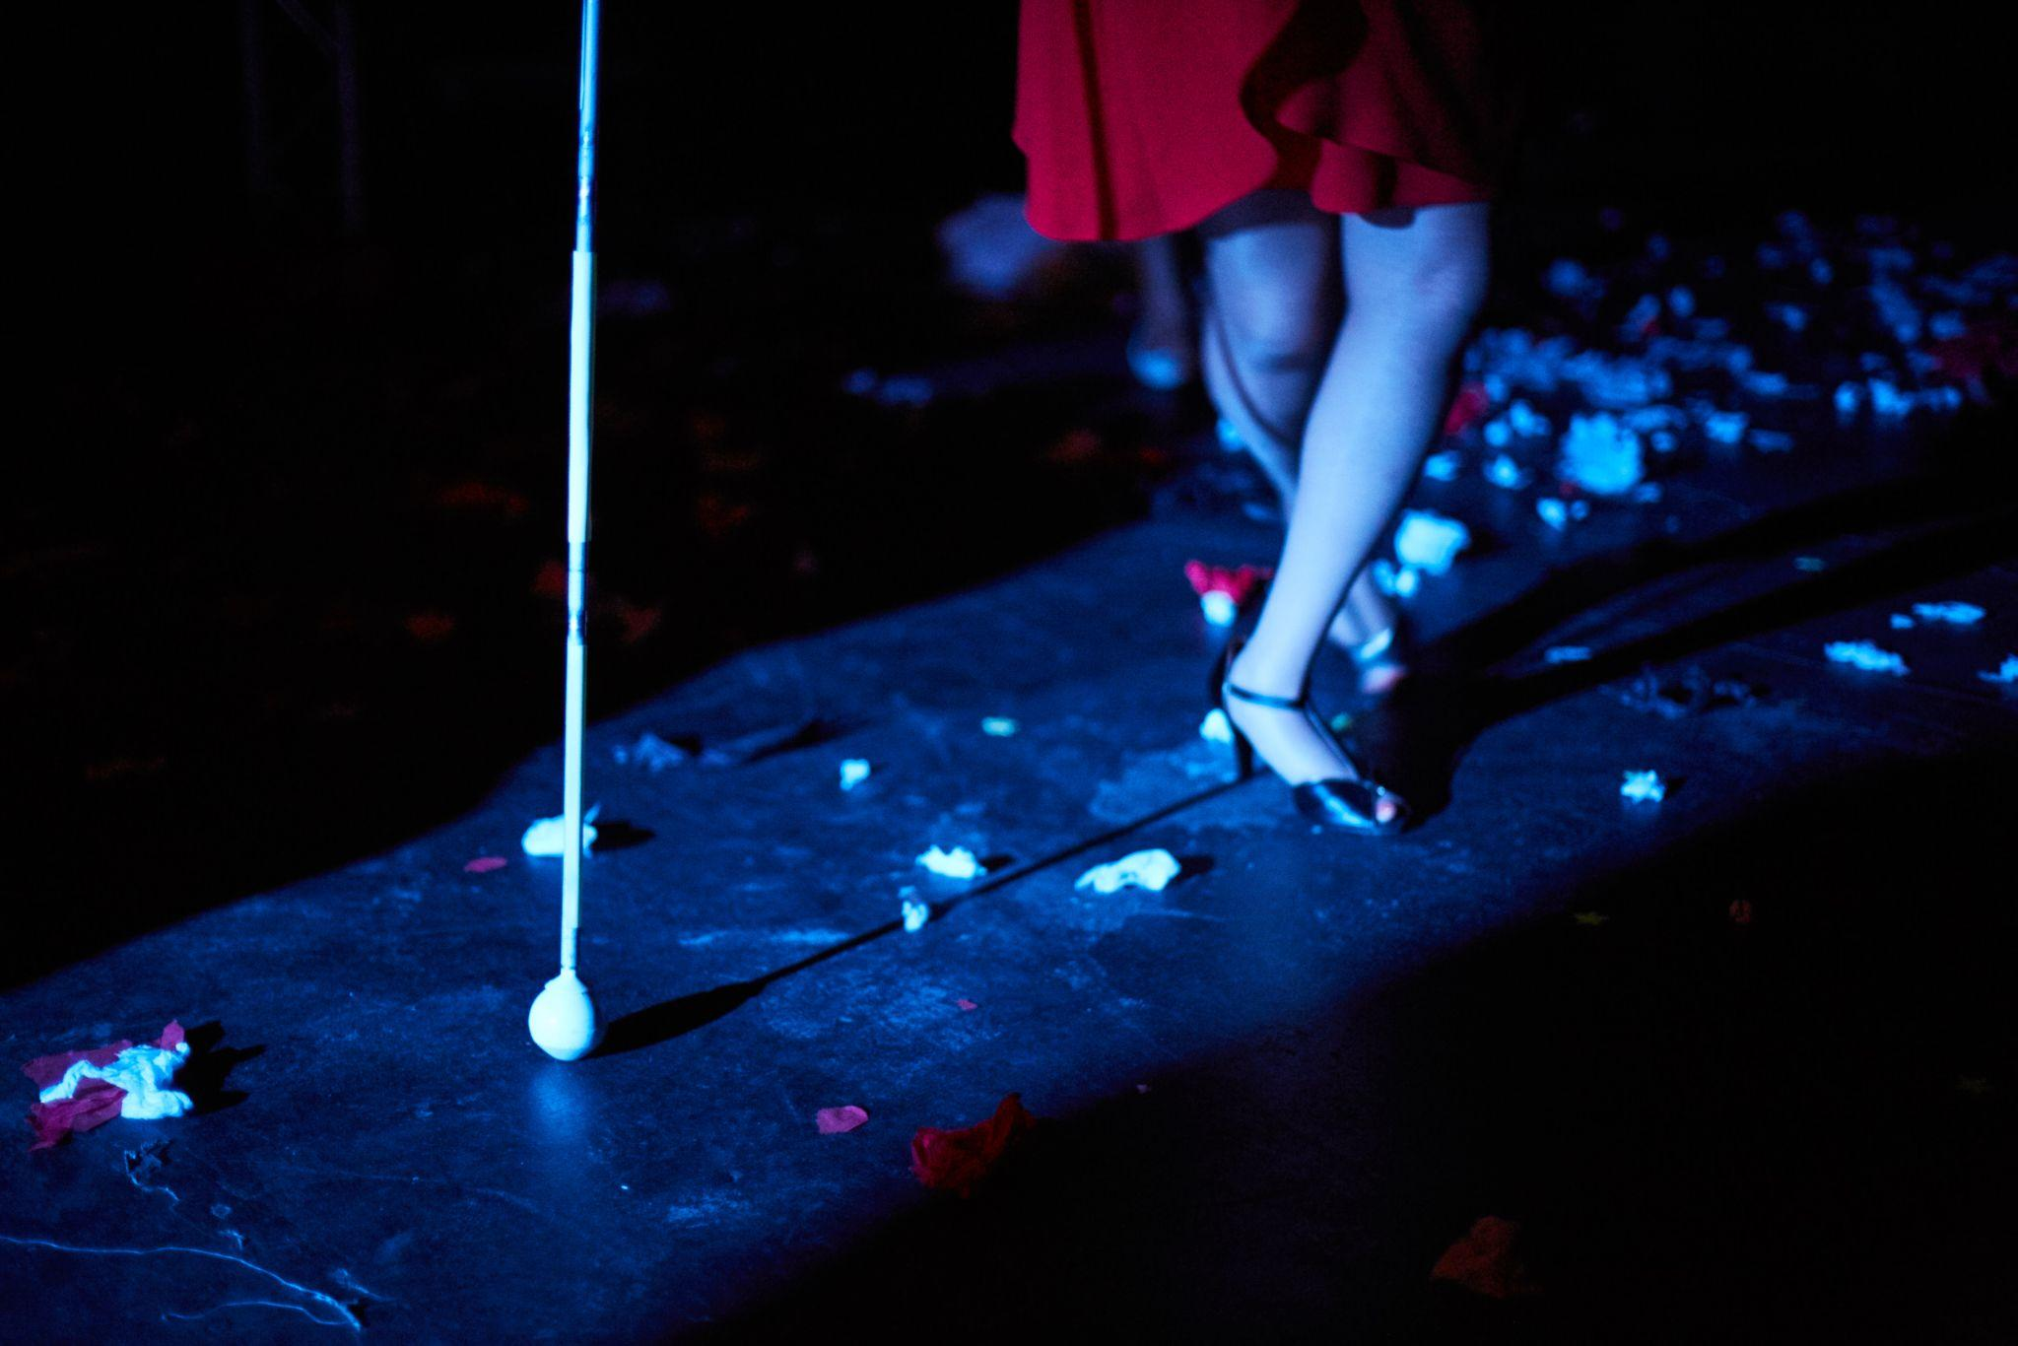

Access

We want to support any access requirements you may have during the recruitment process and will endeavour to make reasonable adjustments where required.

If you have any access needs, or barriers to access that you would like to discuss, please do not hesitate to let us know either before applying as part of your application or at any stage of the process.

