If you require this pack in any other format such as large print, please contact admin@extant.org.uk or call 020 7820 3737 and we will be happy to send it to you.

Enhance Programme Manager

Having gained Arts Council England (ACE) National Portfolio Organisation (NPO) funding for 2023-26 and significant 3-year support from the Paul Hamlyn Foundation, Extant is seeking a talented and creative advocate for inclusion to enable us to build on our work in transforming how theatre venues and companies work with visually impaired audiences.

About Extant
Extant is the UK’s leading professional performing arts company that explores visual impairment to create unique and innovative artistic experiences, placing visually impaired people at the centre of all we do: from the productions we create, to the artists we employ or support to build stronger careers in the sector, to the audiences we perform to and the participants we work with.

In our company, visual impairment is celebrated as a rich source of creative engagement that inspires fresh perspectives.

We fulfil our purpose by:

- Demonstrating artistic excellence, professionalism, and high production values with the express inclusion of visually impaired (VI) performing artists
- Providing sustainable employment and supporting the professional development of visually impaired people working in the arts
- Putting the accessibility for visually impaired audiences at the centre of the artistic process
- Providing opportunities for visually impaired people to get involved in the arts for the first time.
- Ensuring that our company is led by visually impaired people, artistically, managerially and at board level.

Since 2007, we have delivered participatory projects for VI participants alongside professional theatre productions that feature VI artists and welcome VI audiences.

Extant Enhance

Meeting a known demand from VI audiences and participants, Extant Enhance has been developed in partnership with small to medium scale mainstream touring companies to increase the availability of accessible work. Its collaborative approach makes the most of Extant’s resources as a small company and will increase the number, frequency, range, and geographical spread of theatre which meets the needs of VI audiences.

More can be learnt about Enhance here: https://extant.org.uk/access/enhance-2/

This brand-new role of Enhance Training Manager will oversee the programme by managing visually impaired facilitators to deliver Extant Enhance through:

- Recruitment and training of 6 VI Facilitators who will deliver Extant Enhance with 108 theatre companies
- 200 accessible performances for VI audiences
- VI awareness training in 18 venues across the UK
- VI awareness training for practitioners across the UK
- Monitoring and evaluating the impact of the programme to share and embed learning across the theatre sector

The Enhance Manager will coordinate the whole initiative, ensuring that the Enhance programme is delivered by its specially trained facilitators consistently across different types of performance, companies and venues and joined up with relevant sight-loss networks in each region to maximise audience take up for Enhanced touring productions. The Enhance Manager will also respond to additional training and development requests to Extant generated by the Enhance programme.
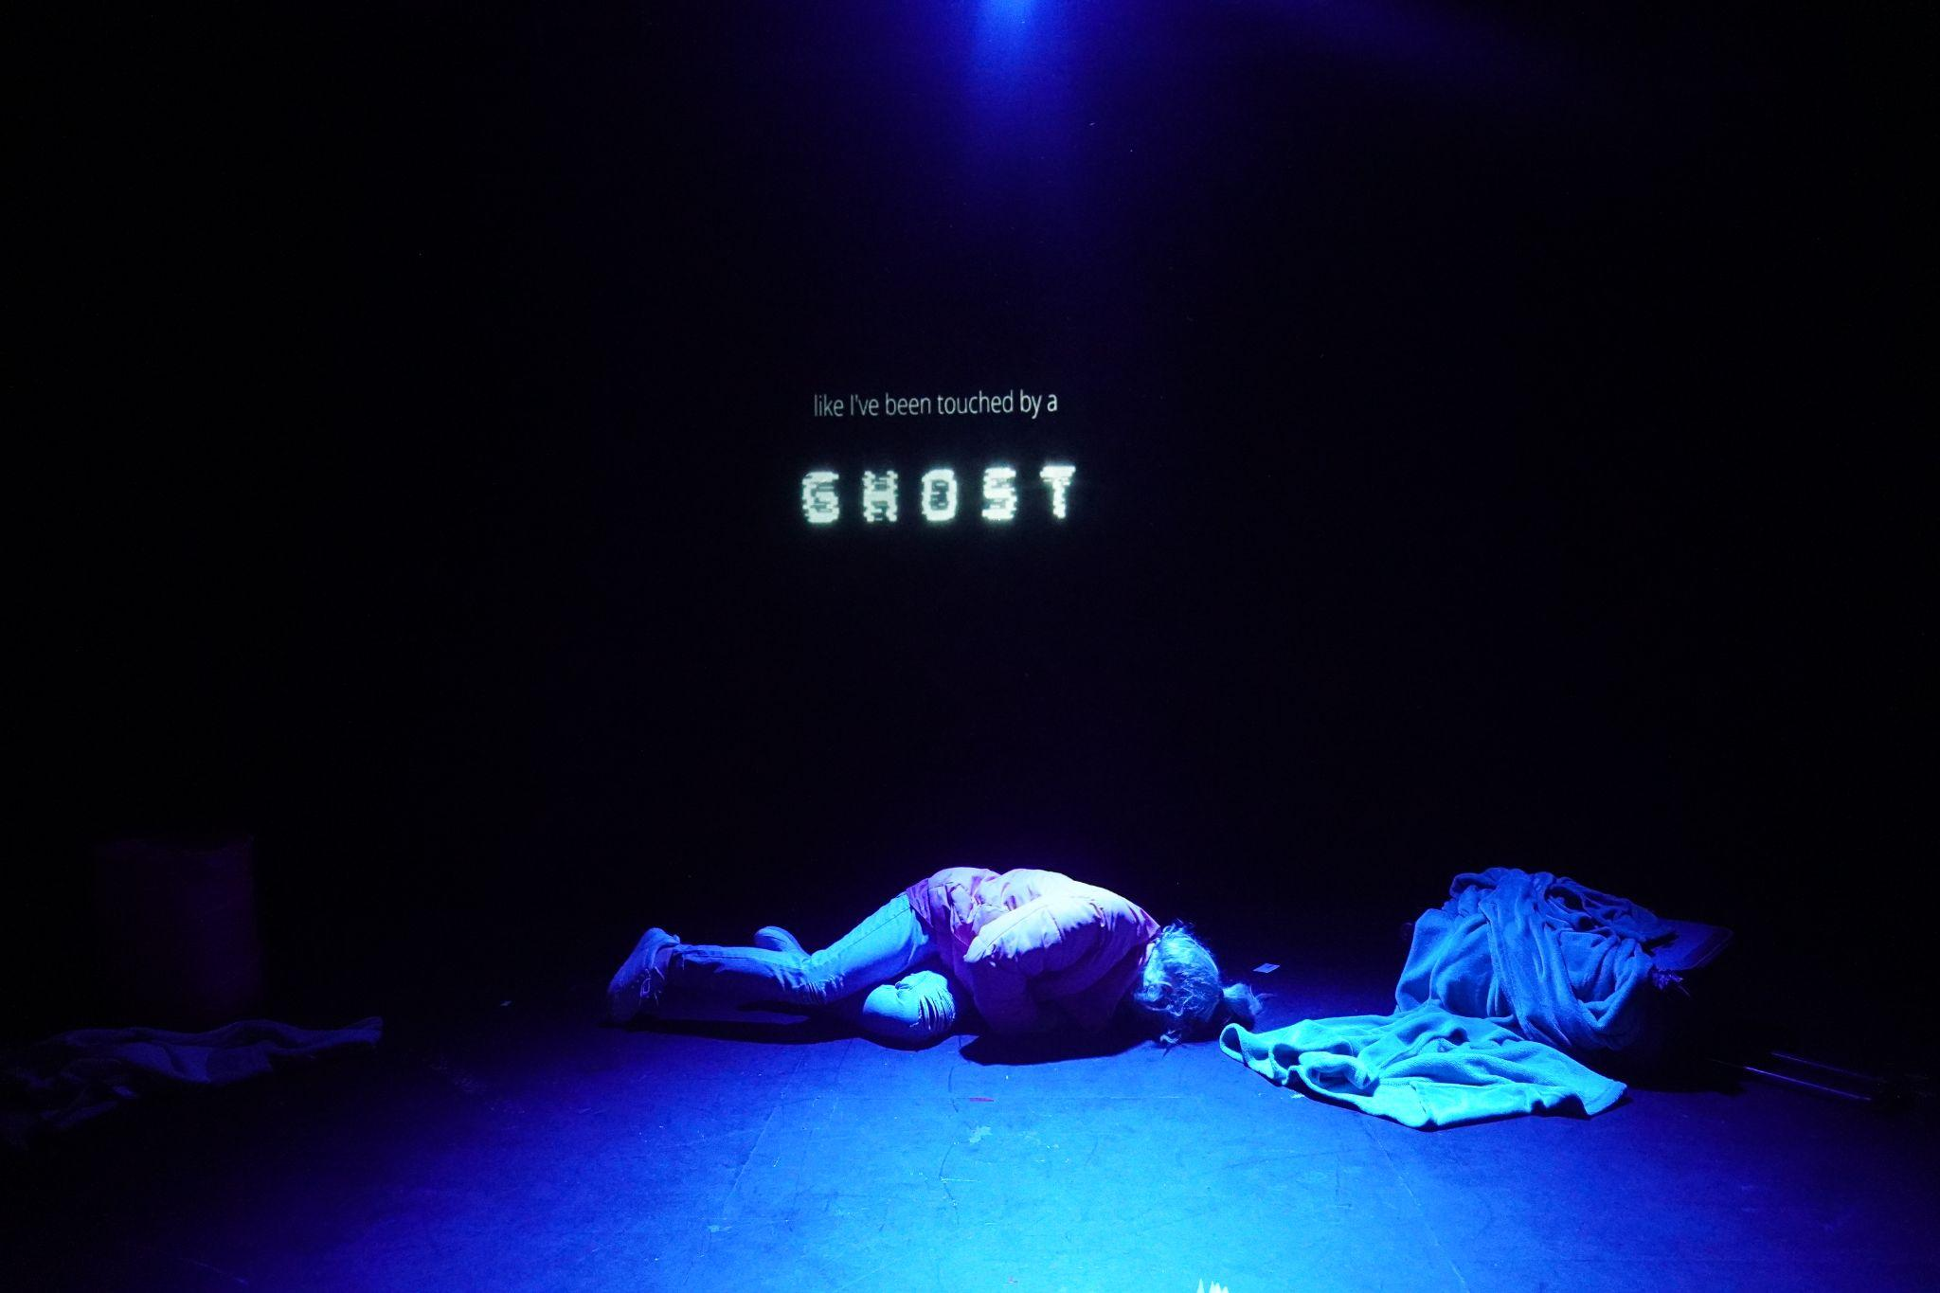

Enhance Programme Manager

The Role

This is a new role created to support an area of expertise we have developed through pilot programmes around VI inclusion across UK venues and audiences.

You will work collaboratively with the Artistic Director/ CEO, Trainee Artistic Directors, Artist Development Manager, partner venues and local organisations for visually impaired people.

We support flexible working, but we expect that you will work from our Brixton office at least one day each week as part of Extant’s small team.

The ideal candidate is someone who understands and has experience of inclusive working, the publicly subsidised arts sector, the context of disability arts in the UK, and is interested in developing a new role. You will be skilled in venue partnership building, designing, facilitating and managing inclusive access programmes.

You will have excellent project management skills, experience in working with theatre makers and arts venues and be willing to work across geographical regions.

This is a 3-year (renewable) part-time contract, 3 days per week (0.6 FTE)

Location: We offer hybrid working, including home, office-based working at our base in Brixton House, 2.06 Carlton Mansions, Brixton House, 385 Coldharbour Lane, London, SW9 8GL and across the UK in partner venue locations
Responsible to: Artistic Director
Line Manages: freelance Enhance programme facilitators
Salary: £30,000 pro rata (£18,000 per annum)
Deadline for applications: 12 noon, Friday 8th September 2023
NB: Please send all documents in Word format to ensure accessibility

The Extant team

Artistic Director/CEO (0.8 FTE)
Director of Operations (0.6 FTE)
Artist Development Manager (0.6 FTE. fixed term until March 2024)
Trainee Artistic Directors (from July 2023)
Administrator (Full Time)
Bookkeeper (0.1 FTE)

Enhance Programme Manager - Job Description

Role description

You will work with the Artistic Director, Trainee Artistic Director, and Artist Development Manager to set up, facilitate, manage delivery, and evaluate Extant’s 3-year Enhance Programme across 18 venues with 108 touring shows linking companies and their audiences from 2023-2026. There will also be opportunities to design and provide bespoke VI access training for other companies and venues on request.

You will develop and build lasting theatre venue partnerships, recruit, train, and support visually impaired (VI) facilitators, adapt VI training for venues and companies, monitoring success and evaluating learning with all stakeholders. You will coordinate and ensure that the Extant Enhance programme is delivered consistently across different types of performance, companies and venues and joined up with relevant sight-loss networks in each region to maximise audience take up for Extant Enhanced touring productions.

Main responsibilities

Managing the Extant Enhance programme from 2023 to 2026, including:

- Establishing and building 18 theatre venue partnerships (6 per year) to co-create Enhance programmes
- Working with Extant’s Artistic Director, Trainee Artistic Director and Artist Development Manager to recruit, train and support up to 18 visually impaired facilitators to deliver Enhance training to venues and touring companies across the UK
- Working with partner venues and Enhance facilitators to establish partnerships with 36 touring theatre companies (6 per venue per year) to deliver 108 ‘Enhanced’ shows
- Working with partner venues and local VI groups and support organisations to increase audiences for Extant Enhanced shows and access to partner venues
- Evaluate and report on the Extant Enhance programme and its impact to investors and partners

Main tasks

Project management

- Creating, agreeing and sharing a clear 3-year project plan with regular review points based on the project proposal to Paul Hamlyn Foundation and the agreed activity plan
- Managing and reporting on the Extant Enhance budget
- Contracting venue and company partners
- Organising recruitment and training of Enhance Programme VI facilitators
- Travelling to partner venues to build partnerships, support training, facilitators and project development
- Establishing and undertaking Enhance programme data gathering, monitoring and evaluation
- Organising and hosting at least 3 Enhance partners’ meetings per year
- Responding to ad hoc requests for VI awareness training for companies and venues, working with them to design, cost and deliver bespoke sessions as required

Administration

- Working from Extant’s Brixton office at least one day per week
- Producing relevant narrative and financial reports for Arts Council, England, Paul Hamlyn Foundation and Extant’s Board as required
- Producing annual programme reports and an evaluative report of the 3-year programme in 2026

Communication

- Establishing and agreeing clear, regular lines of communication internally and externally with all Enhance stakeholders (Extant staff team, facilitators, venue and company partners)
- Attending weekly company meetings (in person or virtually)

Person Specification

Knowledge and understanding

- Knowledge of inclusive working and a full understanding of access issues experienced by visually impaired and other disabled people
- knowledge of the subsidised arts sector in the UK

Experience

- designing, facilitating and managing inclusive access programmes
- venue partnership building
- working with a variety of theatre venues and companies either as a creative or arts manager
- working with disabled artists, especially visually impaired people
- evaluating creative programmes

Skills

- project management skills
- good oral and written communication
- organisational skills, with the ability to juggle competing priorities and maintain good attention to detail
- collaborative people management skills, with the ability to motivate and develop a team working across geographical locations
- A willingness to try new ways of working, self-awareness of own strengths and development areas and ability to reflect on and learn from what has gone well and less well.

Requirements

- The right to work in the UK.
- Willing to undertake an enhanced DBS check.
- Be comfortable working in an environment where guide and other assistance dogs may be present.
- Willing to travel to different parts of the UK and a variety of venues

Salary and Benefits

- £30,000 per annum pro rata (£18,000 per annum)
- 25 days holiday per year plus 8 statutory holidays pro rata (15 days plus statutory holidays)
- Occasional evening and weekend work will be required for which Time off in Lieu will be given
- Pension
- Employee Assistance Programme
- Training and Development
- Theatre ticket budget

Probation and Notice
- 6-month Probation period
- One month notice on either side during the probation period, 3 months thereafter

How to apply

If you wish to apply for this post, please send your CV (no more than 2 pages, including details of two referees) and one of the following:

- Cover letter of no more than 2 pages
- A video no longer than 3 minutes
- A voice recording no longer than 3 minutes

Please send all documents in Word (pdf documents are not accessible) to admin@extant.org.uk by 12pm on Friday 8th September 2023. Interviews will be held on Friday 15th September.

You should also complete a diversity monitoring form which can be found here: www.surveymonkey.co.uk/r/ExtantEqualOpps

If you wish to arrange an informal chat about the post, please email maria@extant.org.uk to arrange this prior to submitting your application.

Access

We want to support any access requirements you may have during the recruitment process and will endeavour to make reasonable adjustments where required.

If you have any access needs, or barriers to access that you would like to discuss, please do not hesitate to let us know either before applying as part of your application or at any stage of the process.

