If you require this pack in any other format such as large print, please contact admin@extant.org.uk or call 020 7820 3737 and we will be happy to send it to you.

Director of Operations

Having been granted Arts Council England (ACE) National Portfolio Organisation (NPO) funding for 2023-26, Extant is excited to be seeking an enthusiastic and experienced Director of Operations to work alongside our Artistic Director, Maria Oshodi to deliver our future plans.

About Extant
Extant is the UK’s leading professional performing arts company that explores visual impairment to create unique and innovative artistic experiences, placing visually impaired people at the centre of all we do: from the productions we create, to the artists we employ or support to build stronger careers in the sector, to the audiences we perform to and the participants we work with.

In our company, visual impairment is celebrated as a rich source of creative engagement that inspires fresh perspectives.

We fulfil our purpose by:
- Demonstrating artistic excellence, professionalism, and high production values with the express inclusion of visually impaired performing artists
- Providing sustainable employment and supporting the professional development of visually impaired people working in the arts
- Putting the accessibility for visually impaired audiences at the centre of the artistic process
- Providing opportunities for visually impaired people to get involved in the arts for the first time.
- Ensuring that our company is led by visually impaired people, artistically, managerially and at board level.

The next 3 years (2023-2026)

This year Extant has launched EVOLVE: a ground-breaking programme to develop new models of culture and leadership shaped by Visually Impaired (VI) creatives.

In 2026 our founding director and CEO, Maria Oshodi, will step down. Instead of carrying out a standard recruitment process to fill her shoes, we are embarking on a three-year project to turn ourselves inside out, invite new disabled leaders into the heart of the company, share what we have learnt so far, and together discover the shape of Extant’s leadership for the future.

EVOLVE comprises three strands:

- Professional development for VI creatives: training for two VI Artistic Directors, who will each work with Extant for 15 months. They will be involved in all strategic and governance decisions, be supported to produce their own public-facing creative work and will embark on a bespoke journey of training and mentoring designed to meet their personal needs.
- Links with Higher Education: developing a new MA programme with Middlesex University, in Radical and Inclusive Arts Leadership, and funding a PhD on the history of Extant in relation to inclusive and innovative arts practice.
- Evaluation and Reflection: working with external facilitators to evaluate the internal processes of EVOLVE. This evaluation will include everyone from the board to the staff, our artists and participants. We aim to embed learning and openness deep into the culture of Extant, to create systems that make these values sustainable and meaningful in everything we do.

This period of growth, connection and reflection will help Extant understand how to move towards the next stage in the company’s life. We also hope that our work will have a positive impact on the wider arts sector, forging relationships and nurturing ideas that will continue to grow in other environments.
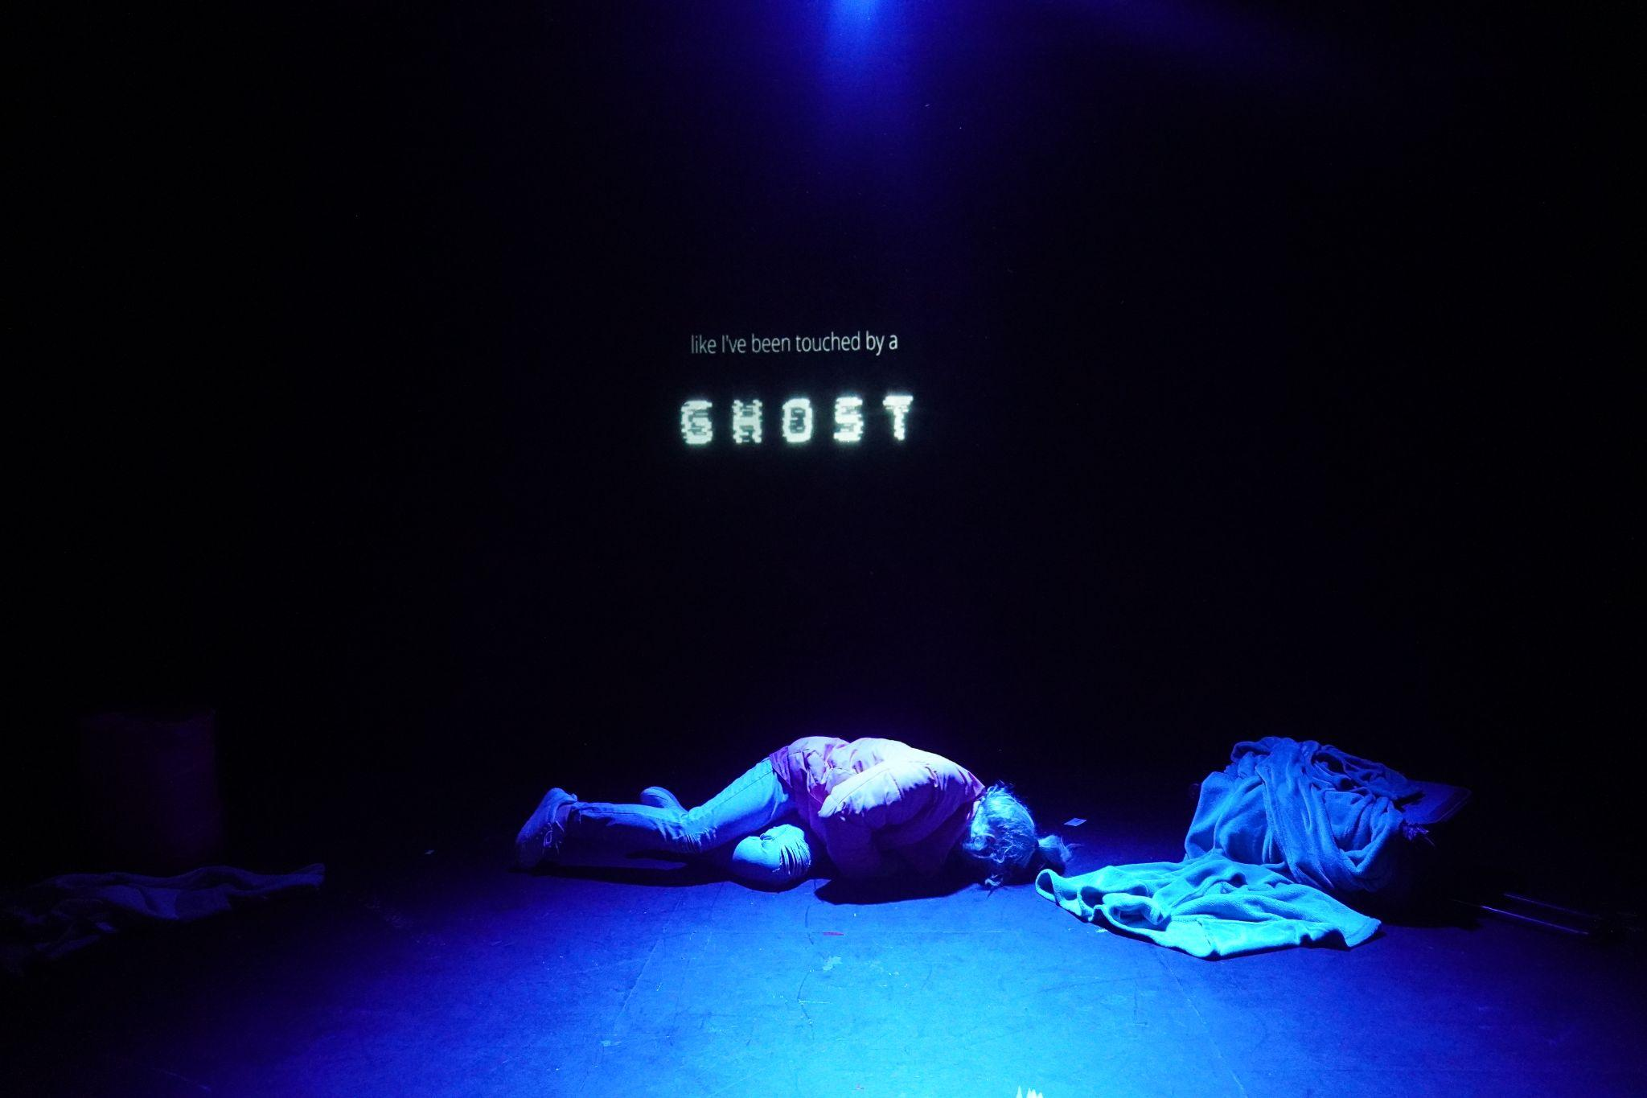

Operations Director

The Role
This is a new role created to support Extant at a time of significant and exciting change. As Operations Director, your main responsibility is to lead Extant’s day-to-day operations (HR, governance, finance, project management and fundraising), ensuring we deliver against our business plan. You will also work with other members of the team on Extant’s broader strategic development. And you will play an active role in Extant EVOLVE – our company-wide process of evaluation and reflection.

You will work collaboratively with the Artistic Director/ CEO, Trainee Artistic Directors, and the Board of Trustees as a member of the Senior Management Team. You will line manage our full-time administrator and Project Co-ordinator, part-time bookkeeper, and freelance workers. We support flexible working, but we expect that you will work from our Brixton office at least one day per week to support Extant’s small team.

The ideal candidate is someone who understands the publicly subsidised arts sector, and/ or the context of disability arts in the UK, and is interested in supporting ethical, radical and inclusive models of working. You will have strong experience of HR, finance, project management and fundraising, good organisational skills and attention to detail, a flexible and adaptable approach and enjoy working as part of a small team.

This is a permanent part-time contract – 3 days per week (0.6 FTE)

Location: We offer hybrid working with the Operations Director expected to be in the office at Carlton Mansions, Brixton House at least 1 day per week
Responsible to: Artistic Director
Line Manages: Administrator, Bookkeeper, Interns, peripatetic freelancers.

The Extant team
Artistic Director/CEO (0.8 FTE)
Director of Operations (0.6 FTE)
Artist Development Manager (0.6 FTE. Fixed term until March 2024)
Trainee Artistic Directors (from July 2023)
Administrator (Full Time)
Bookkeeper (0.1 FTE)

Current Projects:

- Extant EVOLVE
- Artist Development – ongoing artist development for VI artists and arts professionals
- Enhance – training for artists, companies and venues in accessibility for VI people.
- No Dramas – open access improvisation classes for VI people

In early 2023 we also concluded the Pathways Programme of professional development for VI arts professionals, and Superpower Panto – our inclusive and accessible touring show, developed in collaboration with Simply Smiley.

Operations Director - Job Description

Role description

Strategic Development

In partnership with the Artistic Director, you will:

- Actively participate in Extant EVOLVE, working with the staff, the board, and external consultants to reflect on Extant’s processes.
- Develop and maintain our relationships with ACE, funders and other key stakeholders.
- Represent Extant at external meetings and events.

As Director of Operations, you will lead within Extant on the following areas:

Business planning, risk management and evaluation
- Oversee delivery of Extant’s business plan, Monitoring and reporting on progress against milestones and ACE/NPO commitments, including development and management of a robust risk management framework.
- Ensure the impact of Extant’s work is properly evaluated, including by overseeing project evaluations, reports to funding bodies and the quarterly and annual impact assessments required by ACE (managed by the administrator and bookkeeper).

HR and People Management

- review and update Extant’s HR policies and processes to ensure they meet legal requirements and are aligned with Extant’s values.
- Create a supportive an inclusive working environment to support staff wellbeing and ensuring that all workstreams are managed effectively (including through chairing weekly team meetings) and supporting team members’ professional development.
- Ensure fair application of HR policies to employees and freelancers and oversee recruitment of new staff as required.
- Manage the administrator to ensure the smooth running of the office and that HR records are maintained, all data practices are compliant with GDPR, IT and other corporate services are maintained, and contracts are managed effectively.

Fundraising and marketing

- Lead on fundraising for Extant, including developing and implementing a new fundraising strategy.
- Pursue fundraising leads, including preparing grant applications and liaising with potential funders.
- Support the diversification of Extant’s income streams through identifying new consultancy, commercial and other opportunities.
- Develop a new marketing strategy for Extant and work with the administrator on its implementation.

Financial management

- Set and manage project and organisational budgets, in coordination with the Artistic Director and Project Managers
- Maintain management accounts and report to the board, funders and other stakeholders as necessary.
- Work with the bookkeeper to manage day to day finances, including petty cash and monthly payment runs and with the bookkeeper and external accountants to submit annual accounts to the Charities Commission and Companies House

Governance

- Create and compile quarterly board reports and present them at quarterly Board meetings and the AGM.
- Create the annual Trustees Report in collaboration with the Chair and Artistic Director and oversee the creation of the End of Year Accounts in collaboration with the bookkeeper, trustees’ finance sub-committee and external accountants.
- Oversee the completion of relevant reports for the Charity Commission & Companies House

Person Specification

Knowledge and interests

- Knowledge and understanding of the subsidised arts sector in the UK, including the funding ecology, HR practices and governance procedures.
- Knowledge and understanding of charity finance including the use of restricted funds.
- Understanding of the access issues of VI people and other disabled people, or a willingness to learn
- An interest in radical and inclusive arts practice in the UK

Experience

- Demonstrable experience of HR, financial and other operational leadership in a theatre company, arts organisation, charity or small organisation.
- Experience of raising funds from Trusts and Foundations, including managing funder relationships, writing bids, and writing impact reports
- Experience of managing key stakeholder relationships such as with Arts Council England, funding bodies and project implementers.
- Experience leading a team of staff to work to a business plan, setting milestones, reviewing performance and allocating resources.
- Experience managing complex, multi-year budgets.
- Experience in diversifying income streams for the arts/ not for profit sector

Skills

- A flexible, open approach and the ability to work collaboratively as part of a small team.
- Strong people management skills, with the ability to motivate and develop staff and support them to achieve their potential.
- Excellent organisational skills, with the ability to juggle competing priorities and maintain good attention to detail including under pressure.
- Strong relationship-building skills with good oral and written communication.
- A willingness to try new ways of working, self-awareness of own strengths and development areas and ability to reflect on and learn from what has gone well and less well.

Requirements
- The right to work in the UK.
- Willing to undertake an enhanced DBS check.
- Be comfortable working in an environment where guide and other assistance dogs may be present.

Salary and Benefits

- £45,000 per annum pro rata
- 25 days holiday per year plus 8 statutory holidays
- Occasional evening and weekend work will be required for which Time off in Lieu will be given
- Pension
- Employee Assistance Programme
- Training and Development
- Theatre ticket budget

Probation and Notice

- 6 month Probation period
- One month notice on either side during the probation period, 3 months thereafter

How to apply

If you wish to apply for this post, please send your CV (no more than 2 pages, including details of two referees) and one of the following:

- Cover letter of no more than 2 pages
- A video no longer than 3 minutes
- A voice recording no longer than 3 minutes

Please send all documents in Word, as pdf documents are not always accessible, to admin@extant.org.uk by 12pm Monday 19 June 2023.

You should also complete an equal opportunities monitoring form which can be found here: www.surveymonkey.co.uk/r/ExtantEqualOpps

If you wish to arrange an informal chat about the post, please email maria@extant.org.uk to arrange this prior to submitting your application.

Access

We will endeavour to support any access requirements you may have during the recruitment process and make reasonable adjustments where required.

If you have any access needs, or barriers to access that you would like to discuss, please do not hesitate to let us know either before applying as part of your application or at any stage of the process.

