If you require this pack in any other format such as large print, please contact admin@extant.org.uk or call 020 7820 3737 and we will be happy to send it to you.

Trainee Artistic Director

Extant is about to embark on an exciting 3-year new leadership development programme, supporting new visually impaired talent at a higher level within the Company and developing new leadership models in collaboration with our higher education partners. As part of this, Extant is offering two brand new paid Trainee Artistic Director (TAD) opportunities over the next 3 years.

About Extant
Extant is the UK’s leading professional performing arts company that explores visual impairment to create unique and innovative artistic experiences, placing visually impaired people at the centre of all we do: from the productions we create, to the artists we employ or support to build stronger careers in the sector, to the audiences we perform to and the participants we work with.
In our company, visual impairment is celebrated as a rich source of creative engagement that inspires fresh perspectives.

We fulfil our purpose by:
- Demonstrating artistic excellence, professionalism, and high production values with the express inclusion of visually impaired performing artists
- Providing sustainable employment and supporting the professional development of visually impaired people working in the arts
- Putting the accessibility for visually impaired audiences at the centre of the artistic process
- Providing opportunities for visually impaired people to get involved in the arts for the first time
- Ensuring that our company is led by visually impaired people, artistically, managerially and at board level.

The next 3 years (2023-2026)

In 2023 Extant will launch EVOLVE: a ground-breaking programme to develop new models of culture and leadership shaped by Visually Impaired (VI) creatives.

In 2026 our founding director and CEO, Maria Oshodi, will step down. Instead of carrying out a standard recruitment process to fill her shoes, we are embarking on a three-year project to turn ourselves inside out, invite new disabled leaders into the heart of the company, share what we have learnt so far, and together discover the shape of Extant’s leadership for the future.

EVOLVE comprises three strands:

- Professional development for VI creatives: training for two VI Artistic Directors, who will each work with Extant for 15 months. They will be involved in all strategic and governance decisions, be supported to produce their own public-facing creative work and will embark on a bespoke journey of training and mentoring designed to meet their personal needs.
- Links with Higher Education: developing a new MA programme with Middlesex University, in Radical and Inclusive Arts Leadership, and funding a PhD on the history of Extant in relation to inclusive and innovative arts practice.
- Evaluation and Reflection: working with external facilitators to evaluate the internal processes of EVOLVE. This evaluation will include everyone from the board to the staff, our artists and participants. We aim to embed learning and openness deep into the culture of Extant, to create systems that make these values sustainable and meaningful in everything we do.

This period of growth, connection and reflection will help Extant understand how to move towards to the next stage in the company’s life. We also hope that our work will have a positive impact on the wider arts sector, forging relationships and nurturing ideas that will continue to grow in other environments.

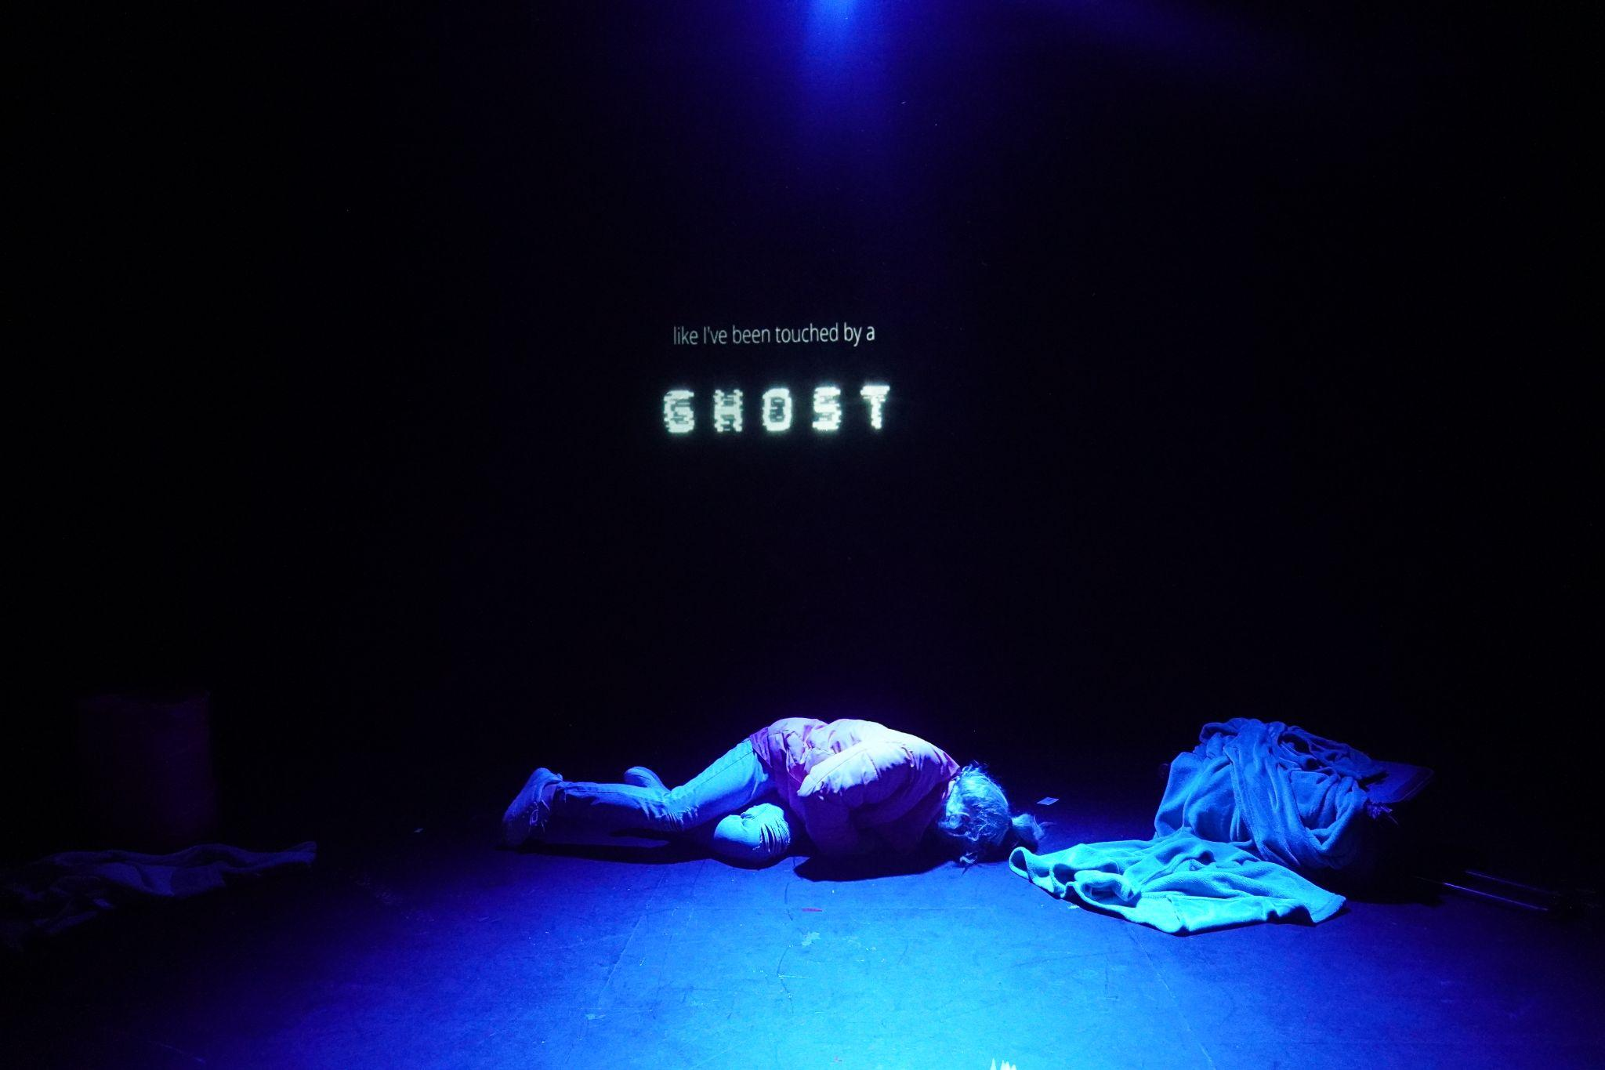

Trainee Artistic Director
The Role

Each traineeship will last 15 months:
TAD 1 – starts July 2023 ends September 2024
TAD 2 - starts July 2024 ends September 2025

15 month 3 day per week (0.6 FTE) fixed term contract - salary £30,000 per annum pro rata.
We will be as flexible as we can to accommodate your existing plans and projects during the traineeship.

Location: We offer hybrid working with the TAD expected to be in the office at our home in Carlton Mansions, Brixton House for some of the traineeship. (We are open to supporting regional candidates to undertake the traineeship and will discuss the best way to do this with successful applicants.)

Responsible to: Artistic Director/CEO (AD/CEO) – who also line manages Extant Project Managers

Works closely with: Executive Director, Artist Development Manager, Board of Trustees.

The Extant team
Artistic Director/CEO - Line manages project managers and TADs
Executive Director - Line manages Administrator and Bookkeeper
Pathways Manager – Fixed term until March 2023
Artist Development Manager – Fixed term until February 2024
Administrator
Bookkeeper

The Trainee Artistic Director Programme

Recruitment Open Session

Extant wish to remove social and access barriers during this recruitment process and so will be holding a drop in recruitment open session on Monday 20 March 2022 10-11am, on Zoom and are happy to arrange one-to-one calls during the recruitment period.

During the session we will explain the traineeship in more detail and answer any questions that prospective candidates might have for us. If you are unable to attend this session, it will be recorded and can be sent to you on request afterwards. If there are any further questions that were not covered in the recording, these can be answered by the Extant team. Please note, you do not have to attend the open day to apply.

To attend the open day on 20 March 10am - 11.30am please email tara@extant.org.uk by 2pm on Thursday 16th March and you will be sent the zoom link.
You can also email us to arrange a one to one conversation any time before the closing date.

Extant will support each TAD over their 15 months with the Company to:

- Develop their own artistic project
- Participate in external training delivered in areas such as governance, arts management, producing and financial management
- Observe and engage with the internal operations of the Company so they can apply their learning from external skills training.
- Work with the AD/CEO on creative access consultations with external stakeholders
- Join the Extant board during their traineeship to guide the evaluation process of the development of leadership for the future constitution of Extant
- Project manage and facilitate No Dramas
- Receive Mentorship throughout their 15 months from disabled industry professionals
- Take part in external shadowing opportunities where appropriate
- The TADs will be supervised by the AD/CEO and supported by the Executive Director and will collaborate in creating their work-plan at the start, where expectations, objectives, roles and responsibilities will be agreed, and regular monthly monitoring meetings set.
- As part of each TAD’s induction they will receive a pack which will clearly explain how the Company works and our systems and processes. They will also be introduced to the staff team, freelancers, and the board.
- Each TAD will be encouraged to make their own decisions while learning the parameters within which a small Company like Extant operates, doing their fair share of admin and project management as part of their training, and appraisal of these tasks will formulate their on-going monitoring.
- Each TAD will have access to all levels of Extant Company business to help their learning from the artistic, operations and board to our major funder relationships. Although the TAD will be involved in much of the Company delivery, the incumbent Extant Executive staff will still ultimately be responsible for key decision making within the organisation to keep the right balance and support in place.

Person Specification

Our Trainee Artistic Director will be an imaginative, ambitious and energised blind or partially sighted candidate with experience of working in the performing arts, or an emerging visually impaired artist with some experience of making theatre.

- You will be able to demonstrate some experience in dynamic creative thinking and delivering this on some artistic level
- You will be able to demonstrate where you have worked in a team collaboratively to bring an idea to fruition and explain the role you played
- You will be able to present persuasive ideas in excellent verbal and written ways and demonstrate ways of adapting your ideas if necessary
- You will have experience in leading performance workshops
- You will have some experience of critical thinking and forming innovative ideas
- You will have some experience of administration or project management
- You will have some experience of financial management and an interest in business development
- You will have some experience of developing marketing for projects or products.
- You will have an active interest and understanding of the arts and disability arts scene
- You will be willing to undertake an enhanced DBS check
- You will be happy to work in an office with a guide dog.

Programme Evaluation Partners

Extant is partnering with ‘Performing Leadership Differently’ (PLD) to embed strong evaluation processes for our leadership training. PLD is a collaboration between Dr Amitabh Rai of Queen Mary University London Business School and ‘Something To Aim For’ (STAF), a diversity sector Support agency. To date, disability has not had a focus in PLD’s research, so working with Extant to include evaluation of our TADs, will introduce an understanding of disability to their learning. This partnership will enable both sides to build a model of good practice, that is collaborative, well documented, and under-pins ways to support the growth of increased numbers of diverse leaders in the future.

Salary and Benefits

- £30,000 per annum pro rata (£18,000 for 3 day week)
- 20 days holiday per year plus 8 statutory holidays pro rata (Total 21.5 days over the 15 month contract)
- Occasional evening and weekend work will be required for which Time Off In Lieu (TOIL) will be given
- Pension
- Employee Assistance Programme
- Training and Development
- Theatre Ticket Budget.

Probation and Notice

- 3 month Probation period
- One month notice on either side during the probation period, 2 months thereafter.

How to apply

This is a national call out to visually impaired artists in the UK.
Please read the programme description and person specification and send a letter as a word document of no more than 2 pages on what makes you particularly suitable to be an Extant TAD.
You can also send a video or audio recording of your application of no longer than 5 minutes if you prefer.

Please note that you are applying for the first Trainee Artistic Director position for July 2023 – September 2024. We will recruit for the second TAD in Spring 2024.

You must be available to work an average 3 days per week from July 2023 – September 2024. We will be as flexible as we can to accommodate your existing plans and projects during the traineeship.

Please send your application to admin@extant.org.uk by 9am Monday 24 April 2023.

You should also complete an equal opportunities monitoring form which can be found here: www.surveymonkey.co.uk/r/ExtantEqualOpps

If you wish to arrange an informal chat about the traineeship, please email admin@extant.org.uk to arrange this prior to submitting your application.

We plan to hold the interviews in the weeks beginning 8 and 22 May at our office in Brixton.

Access

We will endeavour to support any access requirements you may have during the recruitment process and make reasonable adjustments where required.

If you have any access needs, or barriers to access that you would like to discuss, please do not hesitate to let us know either before applying as part of your application or at any stage of the process.

