Image description: Extant logo in purple text on white background, with the Extant website address below, www.extant.org.uk

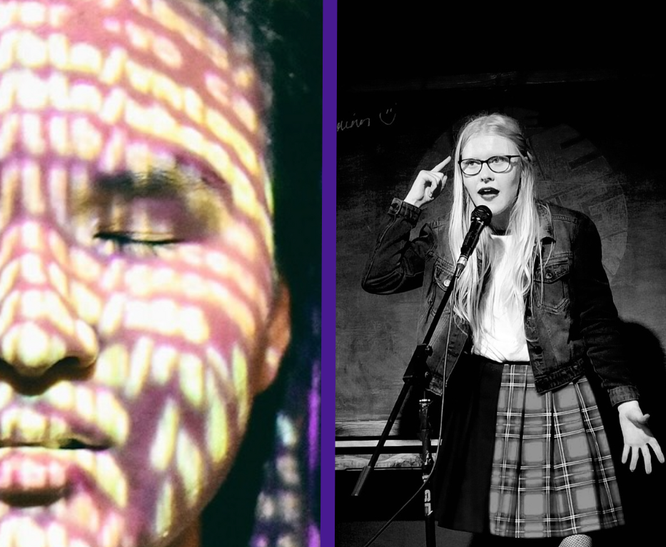

**‘No Future’ and ‘I Dream in Colour’ at Sprint Festival, Camden People’s Theatre**

Monday 27th March 2023 at 7.15pm

Camden People’s Theatre, 58-60 Hampstead Road, London, NW1 2PY

Running time: 1 hour in total, with no interval

**Artist Development at Extant**

Extant is delighted to present two work-in-progress shows: ‘No Future’ by Helena Ascough, and ‘I Dream in Colour’ by Jasmin Thien. When we first discussed bringing a show to our partner venue, Camden People’s Theatre, as part of their annual Sprint Festival, we had planned to offer the opportunity to just one artist. However, we were totally blown away by both Helena and Jasmin’s proposals due to their ambition, creativity and passion. We simply could not choose between them – so we decided to produce them both!

Both Associate Artist shows have been produced for Extant by our Artist Development Manager, Louisa Sanfey, as part of a two-year programme of work supported by the Esmée Fairbairn Foundation, which aims to support and connect blind and visually impaired creatives in their professional development.

**‘No Future’ Creative Team**

Writer/Performer: Helena Ascough

Sound Design & Composition: Tom Sharkett

Outside Eye: Julia Wilson

Consultant: Amelia Cavallo for Quiplash

Voice actor: Karina Jones

**‘I Dream in Colour’ Creative Team**

Writer/Performer: Jasmin Thien

Associate Director: Max Percy

Assistant Director: Lily An

Sound Design: Ian Rattray

Voice actors: Karina Jones, Windson Liong, Erin Tan

**Production Team**

Producer & Director: Louisa Sanfey for Extant

Stage Manager: Alex Rivers

Videography: Aydan Tair

Rehearsal Access Worker: Andrew Baguley

Audience Access Workers:

Tina Meegan, Becky Newman

**About the Cast and Creative Team**

**Helena Ascough** (she/her) is a spoken word performer, theatre maker and actor based in the North West. She gained her PGCE during the pandemic and has worked as a supply teacher in the British school system. She aspires to create thought provoking, inclusive and imaginative work through her lived experience of disability, community led practice and love of storytelling. Helena is an Associate Artist with Extant.

**Jasmin Thien** (she/her) is a fully blind, Bruneian born Chinese actor, writer, spoken word artist and stand up comedian. She came to the UK in 2017 to study at the University of Cambridge. She was shortlisted for the Visually Impaired Excellence Award at the 2022 Edinburgh Fringe and a finalist in the Max Turner Prize for Stand Up Comedy in 2023. She is passionate about exploring difficult topics and ideas in ways that are truthful and nuanced while remaining accessible and relatable to all. Jasmin is an Associate Artist with Extant and is currently touring nationally with Extant’s Super Power Panto. Her play ‘I Dream in Colour’ originally debuted at the National Youth Theatre.

**Lily An** (she/her) is a multidisciplinary London-based artist originally from Hong Kong who became blind in 2014. She is a photographer, filmmaker, art director and emerging theatre maker. She has a BSc (Hons) in Psychology, and studied film at UAL. She has directing, theatre design, lighting design and writing credits with Extant, and recently showcased plays at Canada Water Theatre and the Cockpit Theatre.

**Amelia Cavallo** (they/them) is a blind, USA born theatre practitioner, academic and workshop facilitator. They work as a multi-disciplinary performer, musical director, lecturer and consultant on access and audio description. Currently, they are a Phd candidate at the Royal Central School of Speech and Drama studying intersections of gender, disability and sexuality. They have also performed with disability led theatre companies such as Extant, Graeae and Birds of Paradise as well as with regional theatres such as The New Wolsey, Theatre Royal Stratford East and The Royal Exchange Manchester. Amelia is also co-founder of Quiplash, a theatre company making space for disabled people across the LGBTQIA+ spectrum. Recent publications include a co-written book with Louise Fryer called Integrated Access In Live Performance.

**Karina Jones** (she/her) is an actor, aerialist, and voice coach from Wales. Recent performing work includes Much Ado About Nothing (Sheffield Theatres/Ramps on the Moon), Royal Shakespeare Company rep season 2019-2020, Macbeth (Leeds Playhouse) and playing the lead role in the UK tour of Wait Until Dark. Karina is a also theatremaker and trained as a director and writer with Extant Pathways. She is also a Clore fellow, audio description consultant, and Jerwood Art Live Work Fund Awardee 2021, which she used to develop her aerial practice. In 2020, Karina was the first visually impaired actor to go on as an understudy for a sighted character, which is said to be a bit of RSC history!

**Windson Liong** (he/him) is a bilingual (English/Mandarin) UK-based actor/singer/voice artist, originally from Singapore. To date, he has performed in over 50 productions in countries such as Singapore, United Kingdom, Sweden, China, India and Australia, with 11 musical cast recordings under his belt. As a voice artist, Windson has lent his voice to the popular animation series, Thomas and Friends, as well as AAA games such as Total War: Three Kingdoms, and Hitman 3. He has also been featured in radio plays and documentaries on BBC Radio 4 and BBC World Service, as well as on Audible, narrating various audiobooks by Penguin Random House and Warhammer. Windson is a theatre graduate from Lasalle College of the Arts (Singapore) and a music theatre graduate from Royal Central School of Speech & Drama (UK).

**Max Percy** (he/him) is an award-winning theatre maker and facilitator creating ambitious theatrical experiences. A regular collaborator across various forms including dance, theatre, academia and accessibility, his work explores queerness, asian identity and colonialism whilst experimenting with new forms. He trained at the London Russian Ballet School and East15 Acting School. His most recent show This is Not a Show about Hong Kong, won the Underbelly & New Diorama Untapped Award and a Scotsman's Fringe First 2022.

**Ian Rattray** (he/him) studied music technology at the Royal National College for the Blind in Hereford. He has been working in the audio field for the last 16 years and has experienced a variety of audio based projects. He’s produced a podcast for Disability Arts Online for the last 4 years. Most recently he’s worked with the Arts Council, and the Europe Beyond Access project for the British Council. He recently participated in the Extant Pathways Crew and Design course which has led to several further opportunities in theatre sound design and education.

**Tom Sharkett** (he/him) is a producer, composer and sound designer from Manchester. Having co-founded synth-pop band W. H. Lung, with whom he has released two albums and toured the UK, USA and Europe, he has released his own productions on dance music label Optimo Music as well as remixes for other artists. Tom began working as a sound designer in theatre in 2022 and most recently worked with the Royal Central School of Speech and Drama in the performance of Brecht’s Mother Courage and Her Children.

**Julia Wilson** (she/her) has been making, directing and teaching theatre performance for over 30 years. As well as making solo work she has collaborated with Reckless Sleepers, Chameleons in Dream Time, Dogs of Heaven and Angel Valentine. She has performed nationally and internationally at venues such as Tate Modern, ICA, NRLA, BAC, Southbank Centre, Kampnagal (Hamburg) National Theatre (Bucharest) & Theatre Nantarre (Paris) and as part of Steakhouse Live. More recently she has been working in applied theatre contexts, working as lead freelance practitioner for Odd Arts and is a Curious Minds and TigerMonkey associate.

**Erin Tan** (she/her) has appeared in M. Butterfly, Company, Carmen, and Agatha Christie's The Hollow, where she portrayed Veronica Craye. She's really excited to bring to life the role of Mother in I Dream in Colour.

**Extant Team**

Artistic Director: Maria Oshodi

Executive Director: Tara Hobson

Senior Manager, Operations and Strategy: Fiona Greenhill

Pathways Manager: Caroline Jeyaratnam-Joyner

Artist Development Manager: Louisa Sanfey

Administrator: Jamie Maier

Accounts: Kate Kempin

**With thanks to:**

Arts Council England, Esmée Fairbairn Foundation, Camden People’s Theatre, Lancaster Dukes, Work for Change, The Empty Space, Theatre Deli, Old Diorama

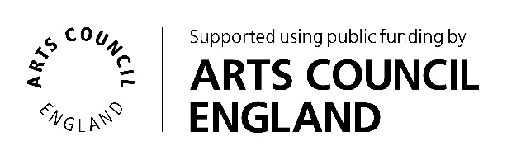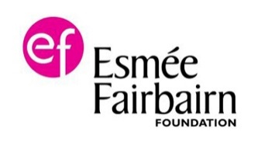

**Help Extant continue to create world class award-winning work by donating £25 for 25 more years.**

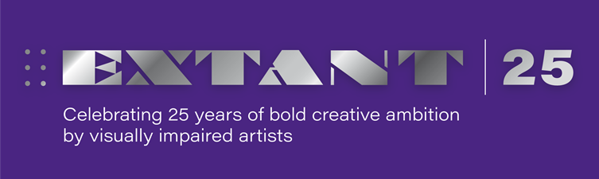**Your kind donations can be made at** [www.extant.org.uk/support-us/](https://gbr01.safelinks.protection.outlook.com/?url=http%3A%2F%2Fwww.extant.org.uk%2Fsupport-us%2F&data=05%7C01%7Clouisa%40extant.org.uk%7C5fc3f8bed22642aa485f08da3a5539b8%7C66f667378dd3462cae478f71da106345%7C0%7C0%7C637886434954682276%7CUnknown%7CTWFpbGZsb3d8eyJWIjoiMC4wLjAwMDAiLCJQIjoiV2luMzIiLCJBTiI6Ik1haWwiLCJXVCI6Mn0%3D%7C3000%7C%7C%7C&sdata=enCMD9W9P6h5IUZ%2B8CXdDKWZFpMWWJX9kPJXPqww5OU%3D&reserved=0)