If you require this pack in any other format such as large print, please contact admin@extant.org.uk or call 020 7820 3737 and we will be happy to send it to you.

Executive Director

Having been granted Arts Council England (ACE) National Portfolio Organisation (NPO) funding for 2023-26, Extant is excited to be seeking a knowledgeable and experienced Executive Director to work alongside our Artistic Director, Maria Oshodi to deliver our future plans.
About Extant
Extant is the UK’s leading professional performing arts company that explores visual impairment to create unique and innovative artistic experiences, placing visually impaired people at the centre of all we do: from the productions we create, to the artists we employ or support to build stronger careers in the sector, to the audiences we perform to and the participants we work with.
In our company, visual impairment is celebrated as a rich source of creative engagement that inspires fresh perspectives

We fulfil our purpose by:
- Demonstrating artistic excellence, professionalism, and high production values with the express inclusion of visually impaired performing artists
- Providing sustainable employment and supporting the professional development of visually impaired people working in the arts
- Putting the accessibility for visually impaired audiences at the centre of the artistic process
- Providing opportunities for visually impaired people to get involved in the arts for the first time
- Ensuring that our company is led by visually impaired people, artistically, managerially and at board level

The next 3 years (2023-2026)

In 2023 Extant will launch EVOLVE: a ground-breaking programme to develop new models of culture and leadership shaped by Visually Impaired (VI) creatives.

In 2026 our founding director and CEO, Maria Oshodi, will step down. Instead of carrying out a standard recruitment process to fill her shoes, we are embarking on a three-year project to turn ourselves inside out, invite new disabled leaders into the heart of the company, share what we have learnt so far, and together discover the shape of Extant’s leadership for the future.

EVOLVE comprises three strands:

- Professional development for VI creatives: training for two VI Artistic Directors, who will each work with Extant for 15 months. They will be involved in all strategic and governance decisions, be supported to produce their own public-facing creative work and will embark on a bespoke journey of training and mentoring designed to meet their personal needs.
- Links with Higher Education: developing a new MA programme with Middlesex University, in Radical and Inclusive Arts Leadership, and funding a PhD on the history of Extant in relation to inclusive and innovative arts practice.
- Evaluation and Reflection: working with external facilitators to evaluate the internal processes of EVOLVE. This evaluation will include everyone from the board to the staff, our artists and participants. We aim to embed learning and openness deep into the culture of Extant, to create systems that make these values sustainable and meaningful in everything we do.

This period of growth, connection and reflection will help Extant understand how to move towards to the next stage in the company’s life. We also hope that our work will have a positive impact on the wider arts sector, forging relationships and nurturing ideas that will continue to grow in other environments.
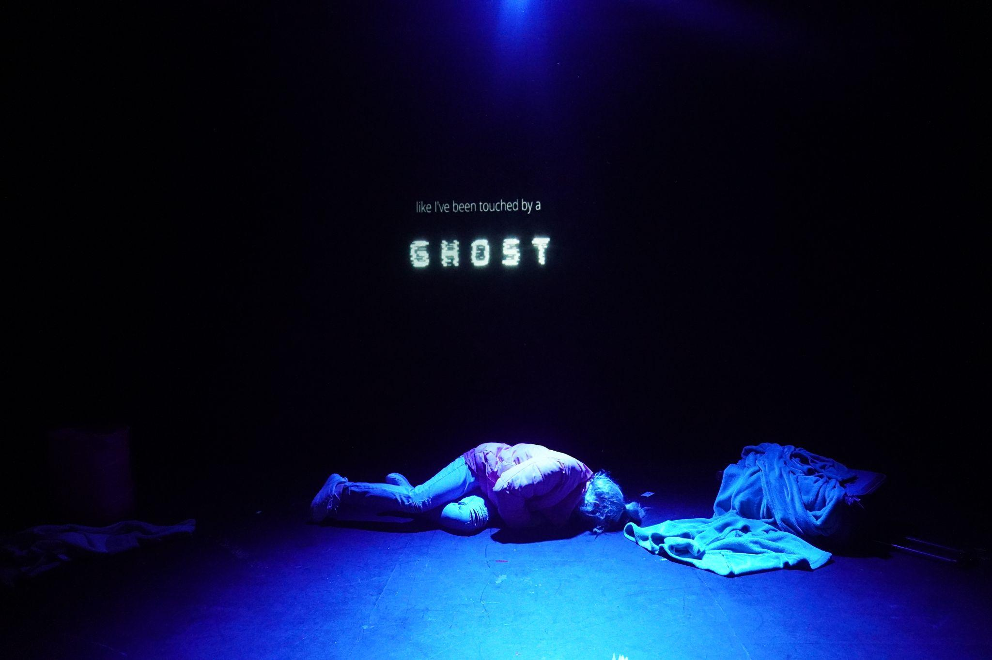

Executive Director
The Role

The Executive Director will work in collaboration with our Artistic Director/CEO Maria Oshodi to form the Extant senior management team.

The ED will provide operational & strategic oversight to ensure the effective delivery of the company’s work. They will be excited to play a fundamental role in our leadership transition programme, participating in, supporting, and embedding Extant EVOLVE over the next three years.

On a day-to-day basis the ED will work closely with the Artistic Director/ CEO, Trainee Artistic Directors, and members of office staff. They will line manage the administrators, bookkeeper and, where appropriate, peripatetic freelancers. The ED will also maintain and develop key relationships with funders (including Arts Council England) and other stakeholders, and with the Board.

They will be also able to support us to maintain the quality and success of our core programme of artistic development and participation.

We are looking for an effective, diplomatic, team-player with experience in senior leadership and operations management to help to lead us as we EVOLVE.

This is a permanent part-time contract – 3 days per week (0.6 FTE)
Location: We offer hybrid working with the Executive Director expected to be in the office at Carlton Mansions, Brixton House at least 2 days per week
Responsible to: Artistic Director
Line Manages: Administrator (job share), Bookkeeper, Interns

The Extant team
Artistic Director/CEO (0.8 FTE)
Executive Director (0.6 FTE)
Pathways Programme Manager (0.4 FTE. Fixed term until March 2023)
Artist Development Manager (0.6 FTE. Fixed term until March 2024)
Trainee Artistic Directors (from July 2023)
Administrator (Full Time - job share)
Bookkeeper (0.1 FTE)

Current Projects:
Pathways
Artist Development
Enhance
No Dramas
In development:
Super Power Panto – touring Spring 2023
Extant EVOLVE

Executive Director - Job Description

Strategic Development

in partnership with the Artistic Director:

- Oversee Extant EVOLVE and our business plan for the next three years
- Drive our relationships with ACE, funders and other key stakeholders
- Develop Extant’s fundraising strategy
- Develop Extant’s marketing strategy
- Represent Extant at external meetings and events

As lead:

- Ensure that the business plan and our ACE/NPO commitments are delivered and that projects remain on track
- Explore and exploit income streams through consultancy and commercial opportunities

Fundraising

- Develop existing funder relationships (including with Arts Council England)
and actively seek to develop new funding streams, including providing impact and financial reports
- Develop effective cases for support and applications for a range of investments
- Oversee data collection and the delivery of quarterly and annual survey related activity by the administrators and bookkeeper

Finance

- Set and manage project and organisational budgets, in coordination with the Artistic Director and Project Managers
- Create and maintain management accounts and report to the board, funders and other stakeholders as necessary
- Work with the bookkeeper to manage day to day finances, including petty cash and monthly payment runs
- Work with the bookkeeper and the external accountants to submit annual accounts to Charities Commission and Companies House

HR and Office Management

- Provide HR oversight for staff, freelancers and board including policies, fees, recruitment, training and contracts
- Develop a training and skills development strategy for the team
- Chair weekly team meetings
- Manage the administrators to ensure:
  - accurate HR records are maintained and all data practices are compliant with GDPR regulations
  - the sufficient provision of services such as insurance and IT support, managing and renewing contracts
  - the smooth running of the office
  - the delivery of the marketing strategy and press activity

Governance

- Create and compile quarterly board reports, attend Board meetings and the annual AGM to present each report
- Create the annual Trustees Report in collaboration with the Chair and Artistic Director, and oversee the creation of the End of Year Accounts in collaboration with the bookkeeper, trustees’ finance sub-committee and external accountants
- Oversee the completion of relevant reports for the Charity Commission & Companies House

Person Specification

Knowledge

- Knowledge and understanding of the subsidised arts sector in the UK, including the funding ecology, HR practices and governance procedures
- Understanding of the access issues of VI people and other disabled people
- Knowledge and understanding of charity finance including the use of restricted funds

Experience

- Demonstrable experience in a senior management role (e.g. Executive Director) in a theatre company, arts organisation or charity
- Experience of raising funds from Trusts and Foundations, including managing funder relationships, writing bids, and writing impact reports
- Experience of managing key stakeholder relationships such as with Arts Council England
- Experience leading a team of staff to work to a business plan, setting milestones, reviewing performance and allocating resource
- Experience manging complex, multi-year budgets
- Experience in diversifying income streams for the arts/ not for profit sector

Interests and Aptitudes

- Ability to work as part of a team, and a willingness to learn and try new things
- Ability to motivate and develop staff when working together
- An interest in radical and inclusive arts practice in the UK
- Willing to undertake an enhanced DBS check
- Happy to work in an office with a guide dog!

Salary and Benefits

- £45,000 per annum pro rata
- 25 days holiday per year plus 8 statutory holidays
- Occasional evening and weekend work will be required for which Time off in Lieu will be given

- Pension
- Employee Assistance Programme
- Training and Development
- Theatre ticket budget

Probation and Notice

- 6 month Probation period
- One month notice on either side during the probation period, 3 months thereafter

How to apply

If you wish to apply for this post, please send your CV (no more than 2 pages please) and one of the following:

- Cover letter of no more than 2 pages
- A video no longer than 3 minutes
- A voice recording no longer than 3 minutes

Please send all documents in Word, as pdf documents are not always accessible, to fiona@extant.org.uk by 9am Monday 16 January 2023.

You should also complete an equal opportunities monitoring form which can be found here: www.surveymonkey.co.uk/r/ExtantEqualOpps

If you wish to arrange an informal chat about the post, please email fiona@extant.org.uk to arrange this prior to submitting your application.

We plan to hold the interviews in the last 2 weeks of January at our office in Brixton.

Access

We will endeavour to support any access requirements you may have during the recruitment process and make reasonable adjustments where required.

If you have any access needs, or barriers to access that you would like to discuss, please do not hesitate to let us know either before applying as part of your application or at any stage of the process.

