Image description: Extant logo in purple text on white background, with the Extant website address below, www.extant.org.uk

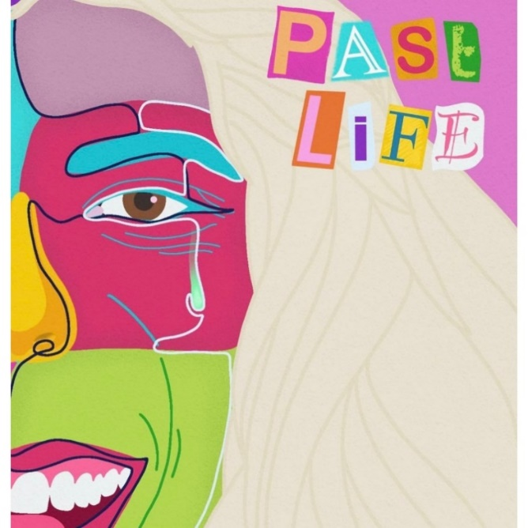

**Past Life by Alice Christina-Corrigan**

**at Bloomsbury Festival 2022**

Sunday 16th October 2022, 7pm  
RADA Studios, 16 Chenies Street, London WC1E 7EX

Running time: 1 hours and 15 minutes - No interval

**Artist Development at Extant**

Extant is thrilled to present *Past Life* by Alice Christina-Corrigan as our first Associate Artist production for 2022/23, and to continue working in partnership with Bloomsbury Festival after the success of our previous Associate Artist shows at the festival.

*Past Life* has been produced for Extant by our new Artist Development Manager, Louisa Sanfey, as part of a two-year programme of work supported by the Esmée Fairbairn Foundation, which aims to support and connect blind and visually impaired creatives in their professional development.

**Past Life Creative Team**

Writer and Performer: [Alice Christina-Corrigan](https://alicechristina.wixsite.com/my-site)

Associate Director: [Madelaine Moore](https://www.maddymoore.com/)

Dramaturg: Sam Rees

Movement Director: Mark Conway for [Play Dead](https://www.playdeadmove.co.uk/)

Producer: Louisa Sanfey for [Extant](https://extant.org.uk/)

Associate Producer: Ella Dale for [Carmen Collective](https://twitter.com/CarmenCollecti)

Stage Manager: Jaimie Wakefield

BSL Interpreter: Jo Ross

Sound & Captioning design: Alice Christina-Corrigan

Originally directed by Sky Cottis

Poster Design: Rhian Jennings

**About the Creative Team**

Alice Christina-Corrigan is a Manchester-based theatre maker who is passionate about breaking the technological barriers of creative access in theatre. Alice's first play Past Life, debuted at Camden People's Theatre this summer. Her work has been supported by Graeae's BEYOND Scheme, OctagonTheatre, CRIPtic Arts and ACE. A short excerpt from her new play Fade was presented as part of the recent Pathways Writers Showcase at Brixton House.

Madelaine Moore is an award-winning Director for stage and screen, and founder of theatre company, The Thelmas. Her work is informed by her interest in disrupting traditional gendered narratives, and tackling big ideas through a feminist lens in surprising and irreverent ways through playfulness with form and drilling down into and subverting common tropes. Credits include: Ladykiller (National Tour, Brits Off Broadway), Algorithms (Soho Theatre), Second Person Narrative (Arcola Theatre)

Sam Rees (MA Text and Performance, RADA/Birkbeck 2020-2021) is a working class theatre artist. His work includes Where is Ban Ki-moon (★★★★ Always Time for Theatre, Camden Fringe Voyeur, The Awkward Corner). His latest piece, Snakehead, will tour nationally in 2023. Other credits include heavymetalsexyanimal (Theatre Deli), 34/3 (CPT), Have You Ever Wondered (Oxford Playhouse) and Stable (Norwich Theatre, Stage Two)

Mark Conway’s work as a movement director includes Land of Our Fathers (West End, UK tour), The Acedian Pirates (Theatre503), Sex With Robots and Other Devices (Live Theatre). I recently joined forces with movement director, Eloise Secker, to become a movement direction duo called Play Dead. Our work includes Lobster (Underbelly EdFringe), Father's Son (Vault Festival) and The Everlasting Club (Short Film).

Louisa Sanfey is the Artist Development Manager for Extant and is a freelance theatre director, dramaturg and audio describer. She has an MA in Theatre Directing from the Lir Academy and has made work in the UK, Ireland and Serbia. Recent work includes *Snake Oil,*an audio play with integrated audio description for Derby Theatre, *Soapbox Racer* (Buxton Fringe), *The War on Terry* (tour) and *BREAKS* (Dublin Fringe/RTE Radio).

Ella Dale is a multidisciplinary artist working across theatre and film as a director, designer and producer. She graduated from Central Saint Martins with a degree in Performance: Design and Practice. She is the Co-Artistic Director of Carmen Collective, the Associate Producer at We Talk Of Horses Theatre Company and the in-house Producer at The Hope Theatre. Recent credits include heavymetalsexyanimal (Theatre Deli), 34/3 (Camden People's Theatre) Snakehead, a medusa story (Theatre Deli) and The Moors (The Hope)

Jo Ross has been a qualified interpreter for over 20 years working in a wide range of settings. She is also trained in physical theatre and supports theatre makers to aim for a parity of experience for Deaf BSL using audiences.

**Extant Team**

Maria Oshodi – Artistic Director

Caroline Jeyaratnam-Joyner - Pathways Programme Manager

Fiona Greenhill - Senior Manager, Operations and Strategy

Louisa Sanfey – Artist Development Manager

Lydia Harrison – Administrator

Mary Hurrell – Administrator

Kate Kempin – Accounts

**With thanks to:**

Arts Council England, Esmée Fairbairn Foundation, Bloomsbury Festival, RADA Studios, Blue Elephant Theatre, Theatre 503, Octagon Theatre, Graeae Beyond Scheme, CRIPtic Arts, Camden People’s Theatre, NSDF

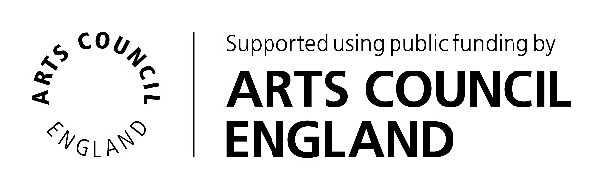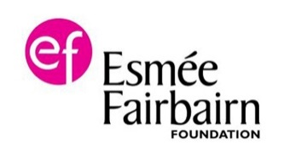

**Help *Extant* continue to create world class award-winning work by donating £25 for 25 more years.**

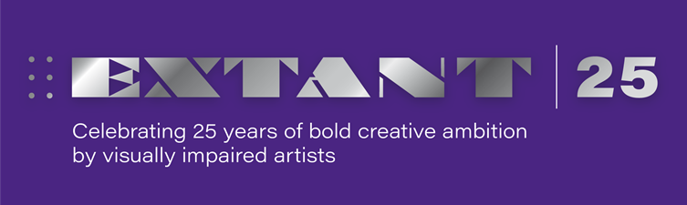**Your kind donations can be made at** [www.extant.org.uk/support-us/](https://gbr01.safelinks.protection.outlook.com/?url=http%3A%2F%2Fwww.extant.org.uk%2Fsupport-us%2F&data=05%7C01%7Clouisa%40extant.org.uk%7C5fc3f8bed22642aa485f08da3a5539b8%7C66f667378dd3462cae478f71da106345%7C0%7C0%7C637886434954682276%7CUnknown%7CTWFpbGZsb3d8eyJWIjoiMC4wLjAwMDAiLCJQIjoiV2luMzIiLCJBTiI6Ik1haWwiLCJXVCI6Mn0%3D%7C3000%7C%7C%7C&sdata=enCMD9W9P6h5IUZ%2B8CXdDKWZFpMWWJX9kPJXPqww5OU%3D&reserved=0)