Extant Trustee Recruitment Pack
Application deadline 30 June 2021
Table of Contents
Introduction 2
About Extant 3
Extant’s structure and the role of the trustee 6
Company legal structure and governance 6
Staff structure 6
The Trustee’s Role 6
Extant’s Board of Trustees meetings and membership 8
Becoming a Trustee 8
Trustee term of office 9
The qualities we look for in our Trustees 9
Being eligible to be a trustee 9
How to apply to be a Trustee for Extant 10
Trustee Application Form 11

An image from Extant’s production of Sheer. Head and shoulders of a woman in a burlesque costume – including a mask and latex medical gloves. She is wearing bandages and red lipstick and holding her arms out, fingers splayed.

Introduction
Thank you for your interest in becoming a Trustee for Extant.

Extant is the UK’s leading professional performing arts company that explores visual impairment to create unique and innovative artistic experiences, placing visually impaired people at the centre of all we do: from the productions we create, to the artists we employ or support to build stronger careers in the sector, or the audience we perform to and the participants we work with.

We are particularly interested in hearing from prospective Trustees with the following experience:

- Paid or voluntary work in the field of equality, diversity and inclusion
- Lived experience of visual impairment
- Arts Management, particularly within an Arts Council England National Portfolio Organisation
- Strategic planning
- Charity governance
- Fundraising from Trusts and Foundations
- Experience as a creative practitioner

Listed below are other areas of experience which are of value on the board:

- Digital
- Campaigning
- Change management
- Business Management
- Event organisation / management
- Finance and accounting
- Knowledge of the arts sector
- Human resources
- Company and charity law
- Marketing / PR / Communications
- Monitoring and evaluation

If you don’t have experience in any of the above areas but think you could bring something to the work of Extant as a trustee, we would love to hear from you.

Extant is committed to diversity in its broadest sense and welcomes applications from all individuals.

About Extant
In our company, visual impairment is celebrated as a rich source of creative engagement that inspires fresh perspectives.

We fulfil our purpose by:
- Demonstrating artistic excellence, professionalism and high production values with the express inclusion of visually impaired performing artists
- Providing sustainable employment and supporting the professional development of visually impaired people working in the arts
- Putting accessibility for visually impaired audiences at the centre of the artistic process
- Providing opportunities for visually impaired people to get involved in the arts for the first time
- Ensuring that our company is led by visually impaired people, artistically, managerially and at board level

Extant is the opposite of extinct. Formed in 1997 Extant was the inspired name chosen by a group of professional visually impaired artists, for the emergence of a new dynamic space, intended to redress our invisibility as artists and explore new creative territories.

Since it began Extant has:
- Pioneered theatre practice with the express inclusion of visually impaired performers and audiences
- Produced ground-breaking national tours
- Toured our theatre productions internationally
- Produced tours of the UK by international visually impaired artists
- Led arts consultancies, seminars and research in access and technology
- Designed outdoor site-specific multi-sensory productions
- Delivered training in education, business and the arts

Our current activity takes place across four areas of work:

Artistic Programme
We make and tour our own professional productions which feature established visually impaired performers, directors, writers, and other creatives.

Our current project, co-commissioned by The Space, is Digital Flight Paths which brings to life on screen our epic multimedia stage production, Flight Paths. Inspired by the Goze, this digital retelling combines animation, aerial movement and creative audio description to tell stories of travel, blindness and migration, taking viewers on a unique, multisensory experience of Japanese cultural history and storytelling, guided by interactive navigation from the Goze.

Artist development
We support visually impaired people who wish to make careers as professional artists.

Pathways is our ground-breaking training programme for visually impaired theatre practitioners, focusing on a different discipline each year: Actors, Directors, Writers and Backstage Staff. Pathways also includes development for the arts sector in how it engages with visually impaired practitioners, this is achieved through:

- Roundtable discussions: For colleagues within the theatre industry to discuss questions and perceived challenges to accessibility for visually impaired artists with a view to improve and increase accessibility for visually impaired artists in the sector.
- VITAP: A half day training session to support a wide range of theatre practitioners with the understanding, skills and confidence to plan and deliver workshops, classes and rehearsal room activity to assist in the inclusion of visually impaired artists.

Audiences and access
We find new ways to make small-scale theatre accessible to visually impaired audiences. Extant has developed an alternative, affordable, low-fi way to support small to mid-scale work with a form of access that is tried and tested to work for visually impaired audience. The consultations are split into two types of support:

- Enhance 1 – Audio Description Dramaturgy: This stage of Enhance offers touring companies within the pre-production and rehearsal process between one and five days of bespoke consultation on the most creative ways to integrate appropriate, aesthetic audio description in their production.
- Enhance 2 – Post Production Support: This stage of Enhance offers touring companies who have already produced their shows, but want to deliver some form of accessibility for visually impaired audiences, an opportunity to work with us to produce programme notes and an appropriate touch tour context to present their notes for visually impaired audiences.

Participation
We create accessible ways for visually impaired people to get involved in the performing arts at a grassroots level. Our current projects include:

- No Dramas: In partnership with London Vision, Extant’s No Dramas sessions are for visually impaired adults looking to have fun, learn new skills and meet new people through drama improvisation.
- Eye Say Eye Say Eye Say: A showcase for visually impaired people wanting to try stand-up comedy. Participants, who became involved through No Dramas, some new, some experienced and all very funny, were mentored by an experienced visually impaired comedian and performed at a showcase event.

We are funded by Arts Council England as a National Portfolio Organisation, and by a number of trusts and foundations whose support enables the delivery of our projects. We also generate income from ticket sales and consultancy.

These are Extant's core values. We ask facilitators who we work with, participants attending our activities, or those who we promote, to uphold these values when working for or representing Extant.
- We respect everyone's accessibility and communication needs, make adjustments where possible and support solutions so that everyone can be included.
- We respect that we all communicate in different ways and encourage participants to engage in whatever way they feel comfortable. Whilst aiming to uphold these values.
- We ask that participants use respectful language, do not use slurs or derogatory terms about others. Repeated behaviour of this nature after warning will result in withdrawal of Extant support.
- We are committed to being an anti-racism environment.
- We are committed to welcoming and respecting people of all faiths
- We are LGBTQ+ inclusive, and our space is welcoming of trans and non-binary people. We ask that everyone respects people's pronouns.
- We will not tolerate bullying or trolling of other participants. Repeated behaviour of this nature after warning will result in withdrawal of Extant support.
- Extant staff prefer to use Identity First Language, "Disabled People", and we use the social model of disability. We understand that people who we work with may choose to use ‘person first’ language, However, we ask that everyone respects the language individuals use to describe themselves, their disability, impairment, or condition.

There is more information about Extant on the company’s website:
www.extant.org.uk

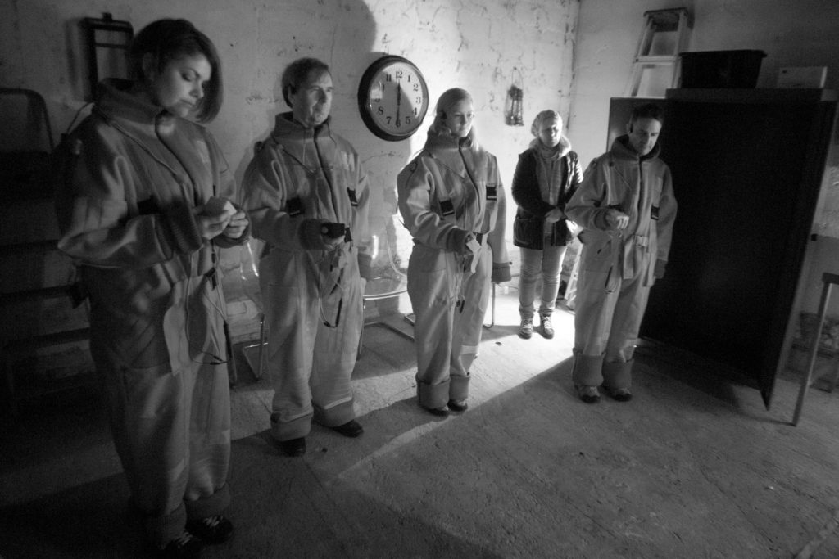

A black and white image from Extant’s project Flatland. Two men and two women standing in the dark. Dressed in neoprene boiler suits, they hold out haptic cubes in front of them which guide their way through the darkness.

Extant’s structure and the role of the trustee

Company legal structure and governance
Extant is a Registered Charity and a Company Limited by Guarantee (which is a ‘not for profit’ company that does not have share capital or any shareholders).

As such, Extant is governed by a group of volunteers: The Board of Trustees, who also act as Company Directors for the Company Limited by Guarantee.

Staff structure
Artistic Director/CEO – 0.8 FTE: The Artistic Director/CEO is the leader of the company and has the vision to lead the company, plan its strategic direction, be a figurehead for the company and reports directly to the Board of Trustees on the running of the company.

General Manager – 1 FTE: The General Manager works closely with the AD/CEO to oversee day to day operations of the organisation, including in-house fundraising and line manages the Assistant Administrator. The General Manager reports directly to the AD/CEO.

Pathways Programme Manager – 0.4 FTE: The Pathways Programme Manager is responsible for the delivery of the Pathways Artist Development Programme, reporting directly to the AD/CEO

Assistant Administrator – 0.4 FTE: The Assistant Administrator is responsible for general administration for the company, with additional responsibility for marketing and communication tasks. This role reports directly to the General Manager.

Bookkeeper – 0.1 FTE: The Bookkeeper is responsible for maintaining financial records and data within the organisation, payroll, accounts payable and accounts receivable. The role reports directly to the AD/CEO.

Other key roles within Extant are fulfilled by a network of freelancers. These roles include project managers, working for limited time on specific projects where additional organisational capacity is needed, and access workers who provide support for visually impaired participants of Extant’s projects.

The Trustee’s Role
The role of the Trustees is to ensure that Extant is fulfilling its mission as a charity, complying with its legal obligations, and supporting the strategic vision and leadership of the charity. Trustees are also key ambassadors for Extant, promoting its work and helping to ensure it follows best practice in the company’s management.

There is more information about the responsibilities of a Trustee in the Charity Commission’s guide: The Essential Trustee

An image from the stage production of Flight Paths. A white woman with dark hair wearing red and hanging upside down from aerial silks.

Extant’s Board of Trustees meetings and membership
Extant’s Board of Trustees meets four times a year for regular Board meetings including our AGM, which usually takes place in October. Meetings are currently held on Zoom, but we hope to return to face to face meetings at a London location in due course. Zoom access will continue to be available for trustees who cannot join in person. Meetings are normally held on a weekday evening.

Trustees also serve on sub-committees dependent on their interests and specialisms, and the needs of the company. These meetings are arranged on an ad-hoc basis.
Sub committees include:
- Finance Sub-Committee
- HR Sub-Committee
- Business Planning Sub-Committee

We occasionally hold additional meetings for strategic planning, review or learning.

Trustees may also work more closely with a member of the staff team to offer advice and support in specialist areas.

Whenever possible trustees attend Extant’s public events and sharings of work.

The board currently comprises:

Mary Paterson – Chair - Writer, Arts Producer
Shamim Ali - Treasurer - Deputy Finance Manager
Ciara Golding - Supporter Experience Manager
Jennifer Gabriele - Account Manager PR & Social
Victoria Harrison - HR Deputy Director, Foreign, Commonwealth and Development Office
Christine Hathway - Administrator and Project Manager

Becoming a Trustee
Potential trustees are welcome to email Extant on trustees@extant.org.uk with any queries about the role, or to request a phone call to discuss it.

We ask all potential Trustees to complete and return the application form which is at the end of this document.

A member of the Board will respond to the application within seven days. If the potential Trustee appears to be a good fit for the charity, a Board member will arrange an informal conversation to share more information about the role and what is involved.

Following this, the potential trustee is invited to attend the next Board meeting as an observer. A member of the Board follows up with the person after the meeting and if both parties are happy to go ahead the new trustee is proposed for appointment, which takes place at the next board meeting, and is ratified at the next Annual General Meeting.

The new trustee is provided with an induction pack, and a ‘board buddy’, to help them settle into their role.

Trustee term of office
Trustees retire from their role on a rotating basis, and are eligible for re-election on retirement.

The current term before retirement is two to four years, and this can vary depending on the size of the board.

The qualities we look for in our Trustees:

- A commitment to Extant and its aims
- A willingness to devote the necessary time and effort, particularly to reading papers and participating at meetings
- Strategic vision
- Good, independent judgement
- An ability to think creatively
- A willingness to speak your mind
- An understanding and acceptance of the legal duties, responsibilities and liabilities of trusteeship
- An ability to work effectively as a member of a team
- A commitment to Nolan’s seven principles of public life: selflessness, integrity, objectivity, accountability, openness, honesty and leadership.

Being eligible to be a trustee

To be legally eligible to be a Trustee you must be aged 18 or over, and must not have an unspent conviction for one or more of the offences listed here:

- Have an IVA, debt relief order and/or a bankruptcy order

- Have been removed as a trustee in England, Scotland or Wales (by the Charity Commission or Office of the Scottish Charity Regulator)

- Have been removed from being in the management or control of any body in Scotland (under relevant legislation)

- Have been disqualified by the Charity Commission

- Are a disqualified company director

- Are a designated person for the purposes of anti-terrorism legislation

- Are on the sex offenders register

- Have been found in contempt of court for making (or causing to be made) a false statement

- Have been found guilty of disobedience to an order or direction of the Charity Commission

All trustees are required to sign a declaration to this effect.

How to apply to be a Trustee for Extant
If you would like to apply to join our Board of Trustees please complete and return the application form, which is on the next page, by Wednesday 30th June and email it to:
trustees@extant.org.uk

If you would like more information, or an informal discussion about the role please email:
trustees@extant.org.uk

Trustee Application Form

Name

Email address

Phone number

Address

Postcode

Occupation

Have you been a volunteer or Trustee before? If so please tell us about what you did.

What skills and experience do you feel you would bring as a Trustee for Extant?

What would you like to get from being Trustee for Extant?

Are you registered with a professional body? If so please tell us which one.

Please confirm whether you are happy for us to hold your contact details in relation to your application.

Yes No

